

# SMART CROP PROTECTION SYSTEM

**USING IOT**

## IBM PROJECT REPORT

### SUBMITTED BY

**JEEVITHA-622119105035**

**KAMALESAH-622119105036**

**KAMALI-622119105037**

**KANISHKAR-622119105038**

|  |  |  |
| --- | --- | --- |
|  | | **JEEVITHA.M** |
|  |
|  |

**\*\*-**

|  |  |
| --- | --- |
|  |  |
|  |  |
|  |  |
|  |  |
|  |  |
|  |  |
|  |  |
|  |  |
|  |  |
|  |  |
|  |  |
|  |  |
|  |  |
|  |  |
|  |  |
|  |  |
|  |  |
|  |  |
|  |  |

### INTRODUCTION

#### 1.1 Introduction

In the world, the economy of many countries is dependent upon agriculture. In spite of economic development agriculture is the backbone of the economy. Agriculture is the main stay of economy. It contributes to the gross domestic product. Agriculture meets food requirements of the people and produces several raw materials for industries. But because of animal interference and fire in agricultural lands, there will be huge loss of crops. Crop will be totally getting destroyed. There will be large amount of loss of farmer. To avoid these financial losses it is very important to protect agricultural field or farms from animal and fire. To overcome this problem, in our proposed work we shall design a system to prevent the entry of animals into the farm by using Laser .Our main purpose of project is to develop intruder alert to the farm, to avoid losses due to animals and fire. These intruder alert protect the crop from damaging that indirectly increase yield of Due to the unavailability of any detection system these attacks kill villagers and also destroy their cropsTherefore a proper detection system could help save their lives and also to the preservation of crops. Also the crops of villagers are destroyed due to frequent interference of animals.

The crops and paddy fields cannot be always fenced. So the possibility of crops being eaten away by cows and goats are very much present. This could result in huge wastage of crops produced by the farmers. This system helps us to keep away such wild animals from the farmlands as well as provides surveillance functionality. It has been found that the odour of rotten egg helps to keep the wild pigs and deer from destroying the crops, hence the farmers manually spray the rotten egg solution on their fields, and firecrackers are used to ward off the wild elephants that destroy the crops. This project is based on surveillance with an animal ward-off system employed in farmlands in order to prevent crop vandalization by wild animals. It involves automation of certain methods used to prevent the wild animals from entering the farmlands and destroying the crops, an electronic fire cracker (for bigger animals, like elephant) and a rotten egg spray (for smaller animals like wild pigs and deer) which have been found useful to ward off the wild animals, we use Haar feature based cascade classifiers for object detection to distinguish between the animal and human.

### LITERATURE SURVEY

**2.1 Wildlife Animal Tracking System using GPS and GSM**

#### International Journal of Engineering Research & Technology (IJERT) ISSN: 2278- 0181

##### 2.1.1 Introduction

This research is meant for the design of wildlife animal tracking system using GPS and GSM. This explains the methodology to overcome the problem of animal injury and mortality due to straying of wild animals out of national parks and wildlife sanctuaries by the use of wildlife tracking system. the coordinates specifying both the latitude and longitude information of an animal informing the concerned officer about the approaching danger. This system is flexible, cost efficient and easy to implement and can be beneficial for monitoring wildlife related complexities like poaching, railway and roadway accidents, destruction of vegetation and threat to human life on the occasion of straying of wild animals out of their habitation zone.

**2.1.2. Block diagram**

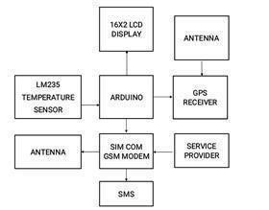

**Figure 2.1** Tracking System using GPS and GSM

This modem requires minimum 4 satellites Global Positioning System modem receives location parameters like latitude and longitude from the satellite. We have also used GSM modem which sense these parameters to particular mobile number through SMS. This information is used to locate the current location using Google map. We have added a temperature sensor to this project. If the animal has fever or if there are some wounds on animal body and because of wounds temperature of animal rises, then it sends SMS to the forest officer so he can give immediate attention. Once user has received the location parameter in the format of text SMS, then he can use this location on the map to find the exact geographical location. To find out the location on printed map is quite difficult. User can read the text SMS and then he can type these parameters in Google map to find the exact location.

**2.1.3 Flow chat**

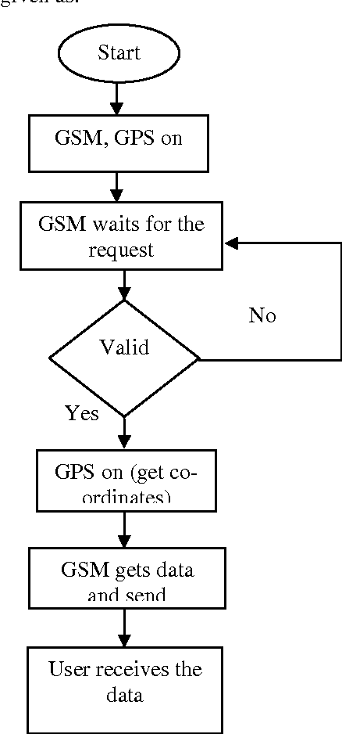

**Figure 2.2** Tracking System using GPS and GSM

##### 2.1.4 Result

The main objective of wildlife monitoring system is to track the location of animals. It is achieved by the GPS and GSM module. GPS antenna is used to track the location of animals. To monitor health of animal temperature is used. The measured parameters are helpful to analys the animal disease or health condition of animal.

**2.1.5 Drawback**

It is difficult to currently a lot of work on building real sensor systems

##### 2.2. IOT in Agricultural Crop Protection and Power Generation

International Journal of Engineering Research & Technology (IJERT) Vol. 9 Issue 05, May2020

#### 2.2.1 Introduction

Agriculture is the science and art of growing plants. Agriculture plays predominant position in the financial improvement of our country and this is the primary profession from many years. To extend the efficiency of the yields and to limit the costs of rural practices we go for smart techniques of agriculture by using IOT technology. Protection of crop during rainy season is major challenge for farmers. By incorporating Greenhouse technology, an environment condition for a crop to grown will created along the various features like sensor based totally monitoring, security, crop safety from excessive rain and automatic roof overlaying facility. Greenhouse is operated in two modes i.e. automatic mode and manual mode. It makes use of telegram app for communicating with the cultivators about various environmental factors continuously. Various sensor nodes are deployed at special locations in the greenhouse. Controlling those parameters are through any remote device or internet services and the operations are completed by means of interfacing sensors, with microcontroller. Power generation and supply is usually a massive problem. This project is also consisting of solar power generation and rainwater harvesting as technology method is implemented along with crop safety. The basic idea beyond using IOT in agriculture is to protect the crops during different seasons. As the many techniques are applied in agricultural sector greenhouse technique is also one of them. As of controlling and monitoring of greenhouse using IOT and some other technologies are implemented. By observing all the technologies which are carried out on the greenhouse, so we are designing a greenhouse system which can control the parameters in the greenhouse. There are different structures of greenhouse are present and their specifications is as mentioned in the below .

##### 2.2.2 Block diagram

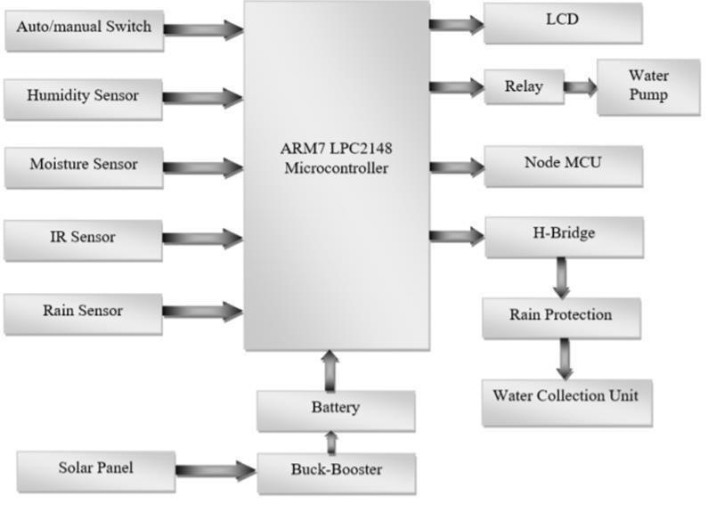

##### Figure 2.3 Agricultural Crop Protection in IOT

###### 2.2.3 Flow chart

To enable the system working in the manual mode we are using IOT technology like telegram bot. In this mode all the controlling and monitoring of greenhouse is carried out through internet. Communication is takes place between farmer and greenhouse. By receiving the monitored values of the parameters the farmer can control the greenhouse anywhere and in anytime. The sequence of operations which are carried out in manual mode as same as automatic mode but instead the system automatically takes process to happen here the farmer will control the whole operation which is far from the land through instant messaging through telegram app using internet services . In this proposed system automatic mode and manual mode of monitoring and controlling operations of the green house are the primary activities and secondary activities which is performed in the green house for cultivating the plants is shown.It makes use of telegram app for communicating with the cultivators about various environmental factors continuously. Various sensor nodes are deployed at special locations in the greenhouse. Controlling those parameters are through any remote device or internet services and the operations are completed by means of interfacing sensors, with microcontroller. Power generation and supply is usually a massive problem. This project is also consisting of solar power generation and rainwater harvesting as technology method is implemented along with crop safety. The basic idea beyond using IOT in agriculture is to protect the crops during different seasons

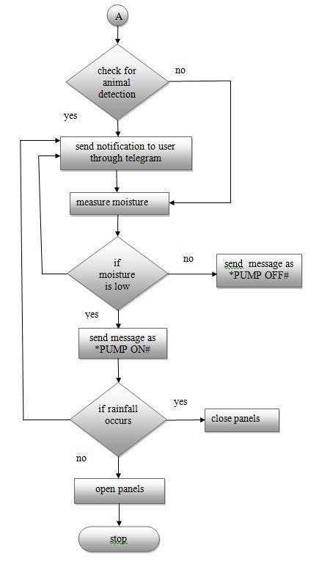

**Figure 2.4** Agricultural Crop Protection in IOT

As the many techniques are applied in agricultural sector greenhouse technique is also one of them. As of controlling and monitoring of greenhouse using IOT and some other technologies are implemented. By observing all the technologies which are carried out on the greenhouse, so we are designing a greenhouse system which can control the parameters in the greenhouse. There are different structures of greenhouse are present and their specifications is as mentioned in the below

###### 2.2.4 Result

The main aim of the project to protect the crops and along with the generation of power using solar panel is established and the parameters to grow the crop according the suitable environment is created using greenhouse structure. Using IOT technology it helps the farmers to control their filed anywhere is simple and now it is cost effective. This system helps to solve power supply problem and this helps in yielding.

###### 2.2.5 Drawback

By using these techniques, the farmer gets benefitted by the reduced water consumption and reduced soil evaporation loses. Initially irrigation project cost is high because of this, taxes to the cultivator is more in the form of levy.

###### 2.3 Smart Intrusion Detection System For Crop Protection And Monitoring

International Research Journal of Engineering and Technology (IRJET) Volume: 08 Issue: 03 | Mar 2021

2.3.1 Introduction

Drought is a major issue faced by farmers these days next to crop vandalization. Since flora and fauna co-exist together it is very vital that we monitor the animals that live close to the crop fields. The main focus on this paper is to provide solution to resolve crop damage by animals. Smart intrusion detection system aims to help farmers detect the presence of animal and offer a warning. Our system's sole purpose is to prevent wild animals from entering the property. We are using a global system for mobile communication that will transmit a message to the farm owner in advance. The camera is used to track the arrival of intruders or creatures, and would be telecast to the owner; at night, we use a flash light to get clearer images of the animals. Our system often addresses the need for a practical approach by allowing the farmer to switch the system on or off using a timer or manually depending on the situation.

2.3.2 Block diagram

The proposed system is classified into four parts – Solar panel part, sensor part, controlling part, alarm part. Three PIR sensors, one ultrasonic sensor, and one seismic sensor make up the sensor portion, which aids in the detection of any animals or birds near the crop area. which aids in the detection of any animals or birds near the crop area. PIR sensors can sense activity up to 10 meters away. By using an ultrasonic sensor distance is measured Camera is enabled in such way that the live feed is visible to the farmer at all times. Using GSM an alert will be sent to the farmer in case of animal presence near the field which will in turn activate the speaker to scare the animal away from the crops.

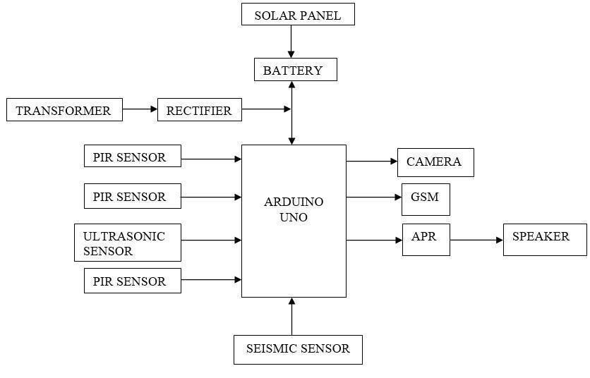

**Figure 2.5** Smart Intrusion Detection System For Crop Protection

This proposed system uses renewable energy (the sun) in the form of solar panel which stores the energy. During daytime, solar panel is used to produce power for the system. At night, the stored energy is utilized to run the system. PIR sensors can sense activity up to 10 meters away. By using an ultrasonic sensor distance is measured Camera is enabled in such way that the live feed is visible to the farmer at all times. Using GSM an alert will be sent to the farmer in case of animal presence near the field which will in turn activate the speaker to scare the animal away from the crops. This proposed system uses renewable energy (the sun) in the form of solar panel which stores the energy. During daytime, solar panel is used to produce power for the system.

**2.3.3 Flow Chart**



**Figure 2.6** Smart Intrusion Detection System For Crop Protection Flowchart

2.3.4 Result

There are three PIR sensors in the device.. This sensor is mainly used to detect elephant intrusion. The appearance of an animal is shown on the LCD. Farmer can continuously monitor the farmland by using the camera attached to the system. During the day, solar panels are used to power the system. The machine is powered up at night using the stored electricity.

2.3.5 Drawback

Agriculture is the economy's cornerstone, but animal intrusion in farm fields can result in major crop losses. Indeed, the farmer's dilemma had become a big issue by the end of the century of greatest agricultural growth

###### 2.4 Smart AGRO Using ARDUINO and GSM

International Journal of Emerging Technologies in Engineering Research (IJETER) Volume 5, Issue 3, March (2017)

2.4.1 Introduction

In this project came from the countries where economy is based on agriculture and the climatic conditions lead to lack of rains & scarcity of water. The farmers working in the farm lands are solely dependent on the rains and bore wells for irrigation of the land. Even if the farm land has a water-pump, manual intervention by farmers is required to turn the pump on/off whenever needed and also the farmer need safety for their components and they need vegetable safety from wild animals. The aim of our project is to minimize this manual intervention by the farmer, which is why we are using a ARDUINO UNO. If the wild animals is entering inside the farm land means will be altered. So this project is very useful to modern agriculture.

###### 2.4.2 Block diagram

In this design we are using many equipments to simultaneously work according to the design. For power supply we are using 12V DC Adaptor and to regulate the required voltage we are using DC Voltage Regulator. To sense the temperature around the field and humidity in the air around the field we are using DHT11 Temperature & Humidity Sensor. To sense the soil moisture in the soil we are using Soil Moisture Sensor. Both the senor will be connected to the Arduino. We are also using a GSM Modem in the design to send the information about the parameters to the mobile phone of the user. In this we have designed the system in that way that if the parameters go high than the threshold value than it will send the user a text message about the parameters going high and it will alert the user about the field. We are using a LCD display in the system which will be connected to the project. In this display it will continuously keep on showing the parameters. In this we are using a Relay which is connected to the Relay Driver. The Relay driver will control the relay. And the will control the water pump. When the parameters will go high it will automatically on the relay and the relay will trigger the water pump. In this we have programmed the computer language in the the proposed system we are using arduino and various sensors like IR sensor and soil moisture sensor, senses the environment and send signal to Arduino**.**

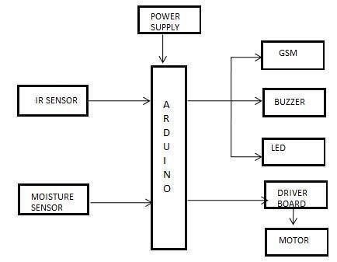

**Figure 2.7** Smart AGRO Using ARDUINO and GSM

Arduino has inbuilt At mega processor which process the data and send it to database. The IR sensor detect the motion of animal and send the information to user using GSM module, at the same time buzzer and led will automatically ON in the agriculture land. They are all connected with arduino device. Soil moisture sensor is used to find the moisture of the land, it also with Arduino . Automatically control the motor with the help of driver board. which is why we are using a Arduino uno. If the wild animals is entering inside the farm land means will be altered. So this project is very useful to modern agriculture. A major challenge in agriculture is to prevent agriculture land from animals.in early days Agriculture land belonging to individual farmers are maintain using fencing. Now we are implementing new technologies.so we are using IRSENSOR to detect the motion of animal. There have been technological advancements in agriculture sector from the last decades and growth of the irrigated areas.85% of available water resources are used for agricultural lands.

###### 2.4.3 Flow chart

Even if the farm land has a water-pump, manual intervention by farmers is required to turn the pump on/off whenever needed and also the farmer need safety for their components and they need vegetable safety from wild animals. The aim of our project is to minimize this manual intervention by the farmer, which is why we are using a Arduino uno. If the wild animals is entering inside the farm land means will be altered. So this project is very useful to modern agriculture. A major challenge in agriculture is to prevent agriculture land from animals.in early days Agriculture land belonging to individual farmers are maintain using fencing. Now we are implementing new technologies.so we are using IRSENSOR to detect the motion of animal. There have been technological advancements in agriculture sector from the last decades and growth of the irrigated areas. 85% of available water resources are used for agricultural lands. A major challenge in agriculture is to prevent agriculture land from animals.in early days Agriculture land belonging to individual farmers are maintain using fencing. Now we are implementing new technologies.so we are using IRSENSOR to detect the motion of animal. So this project is very useful to modern agriculture. A major challenge in agriculture is to prevent agriculture land from animals.in early days Agriculture land belonging to individual farmers are maintain using fencing. Now we are implementing new technologies.so we are using IRSENSOR to detect the motion of animal. There have been technological advancements in agriculture sector from the last decades and growth of the irrigated areas. 85% of available water resources are used for agricultural lands.

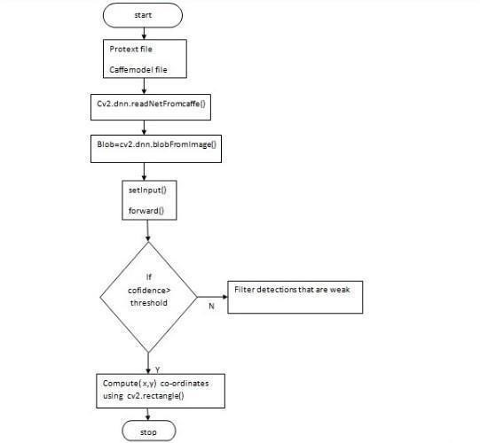

**Figure 2.8** Smart AGRO Using ARDUINO and GSM

###### 2.4.4 Result

A major challenge in agriculture is to prevent agriculture land from animals. so we are using IRSENSOR to detect the motion of animal. To find the moisture content of the land, we use soil moisture sensor in the land. Using these data the diver board controls the automatic ON and OFF of motor. the system has searching capabilities, helping the user with a full-text query language and phrase suggestions, allowing a user to use APIs to perform operations based on data points, streams and triggers.

**2.4.5 Drawback**

Less accuracy and Short range communication

###### 2.5 Development of IoT based Smart Security and Monitoring Devices for Agriculture

International Journal of Recent Technology and Engineering (IJRTE) ISSN: 22773878

2.5.1 Introduction

Agriculture sector being the backbone of the Indian economy deserves security. Security not in terms of resources only but also agricultural products needs security and protection at very initial stage, like protection from attacks of rodents or insects, in fields or grain stores. Such challenges should also be taken into consideration. Security systems which are being used now a days are not smart enough to provide real time notification after sensing the problem. This device can be controlled and monitored from remote location and it can be implemented in agricultural fields, grain stores and cold stores for security purpose. This paper is oriented to accentuate the methods to solve such problems like identification of rodents, threats to crops and delivering real time notification based on information analysis and processing without human intervention.

2.5.2 Block diagram

In terms of security aspect IR/PIR sensor is used to identify the animals and human entry in the field and buzzer is used in altering them. While looking in terms of monitoring aspects the presence of water in the well is monitored and then the moisturizing level of the soil and the temperature of the surroundings are monitored.

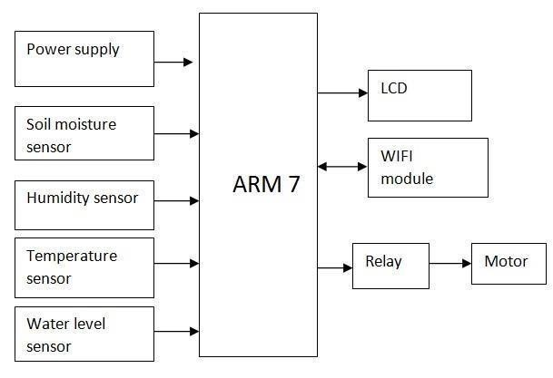

**Figure 2.9** Smart Security and Monitoring Devices for Agriculture

These values are monitored by using respective sensors and are feed to the controller. The pump control button will present on the webpage and can be controlled based on temperature and moisture level. The water level in the well is stated in two states . If the water level is monitored as International Journal of Pure and Applied Mathematics Special Issue empty instead of pump motor is used for water extraction. In case of intruder the farmer will be alerted through webpage. Here when the intruder arrives the buzzer will be alarmed to scare the animals and give initial level of security. Then by using WIFI Module the values are stored in SQL. From that the values are displayed in webpage using PHP server. Then the web hits the server for every seconds and the new data will be refreshed. able to monitor the situation of the field at any instance as the data are updated for every minute The proposed system will provide overall security for the agricultural storage area. . With the help of IoT an alert can be given regarding the animal entry and the forest fire. . IoT systems need to provide the services to anyone at anytime and anywhere. IoT applications can be proved to be very effective in the agriculture . The system detects fire, alerts the user and also resolves the problem without human intervention. It also detects the movement of intruders, notifies this to the owner and executes an action for this event

2.5.3 Flow chart

In the proposed scenario, the research problem is to develop intelligent security systems with ability to analyze data and transmit information over network to the remote location. Literature survey gives the notion about present work done in field of agriculture security and IoT. This can be enhanced by integrating few new technologies with present scheme. Current IP based CCTV security cameras require network connectivity for monitoring from remote location. It doesn’t has ability to notify user by analyzing data. In the device, basic sensors and electronic devices are used The sensory information are analyzed in order to activate electronic devices and raspberry pi is used as a server to analyze data and transmit information to user.

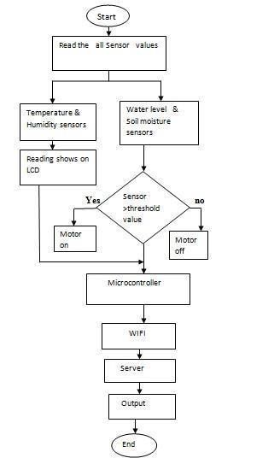

**Figure 2.10** Smart Security and Monitoring Devices for Agriculture

After data processing, on application interface, a website link will be sent to the user along with timestamp and information. Based upon the distance calculated by ultrasonic ranging device, repeller will be activated with a particular frequency within range 30kHz to 65kHz, which is aversive to rodents.

2.5.4 Result

Internet of Things is used with IoT frameworks in order to easily view, handle and interact with data and information. Within the system, users can register their sensors, create streams of data, and process them. In addition, the system has searching capabilities, helping the user with a full-text query language and phrase suggestions, allowing a user to use APIs to perform operations based on data points, streams and triggers.

2.5.5 Drawback

The significant challenge facing in agriculture is the security to the agricultural products at very initial stages. At present there are no proper systems which can provide security. The security system for agriculture is implemented which is highly accurate in notifying user and thus the activation of repeller based on the information gathered from various sensors.

###### 2.6 Implementation Of Crop Protection System Against Wild Animals Attack

International Journal of Emerging Technologies in Engineering Research (IJETER) Volume 5, Issue 3, March (2019)

2.6.1 Introduction

In the field of agriculture, the crop yield is getting reduced by the wild animals attacks. The important thing is to prevent the animals which moves from the forest into the agricultural land, has become one of the rising factor that affects agriculture. The farmers are suffered a lot by the animal attacks. Sometimes people also lost their lives while they try to banish the animals out of their place. The animals enter into the agricultural land because of the lack of water resources in the forest areas and deforestation.. With the help of IoT an alert can be given regarding the animal entry and the forest fire. The animals enter into the agricultural land because of the lack of water resources in the forest areas and deforestation.

2.6.2 Block diagram

Whenever the PIR sensor detects the presence of object, the camera starts capturing the pictures. The animal in the picture is identified by the use of image processing. The ultrasound can be produced from the repeller devices at three different frequencies according to the type of animal identified (In addition with that a flash light and fog machine can also be used). In case if two different animals that enter into the field is identified, first the sound can be produced to turn the animal which produces high risk. Along with this a fire sensor is used to indicate the forest fire and to avoid the spreading of fire from forest and alert message is send through IoT. ’Internet of Things’ based device which is capable of analyzing the sensed information and then transmitting it to the user. This device can be controlled and monitored from remote location and it can be implemented in agricultural fields, grain stores and cold stores for security purpose. The farmers are suffered a lot by the animal attacks. Sometimes people also lost their lives while they try to banish the animals out of their place.

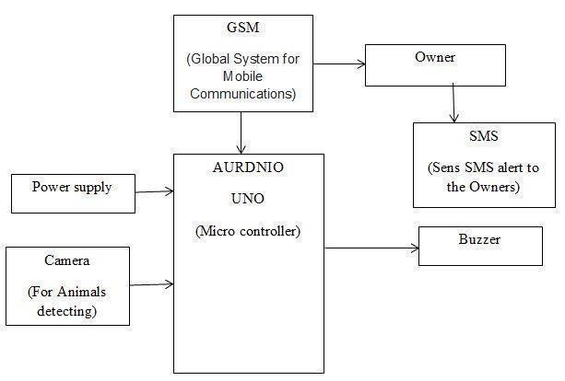

**Figure 2.11** Crop Protection System Against Wild Animals Attack

2.6.5 Flow chart

The farmers are suffered a lot by the animal attacks. Sometimes people also lost their lives while they try to banish the animals out of their place.

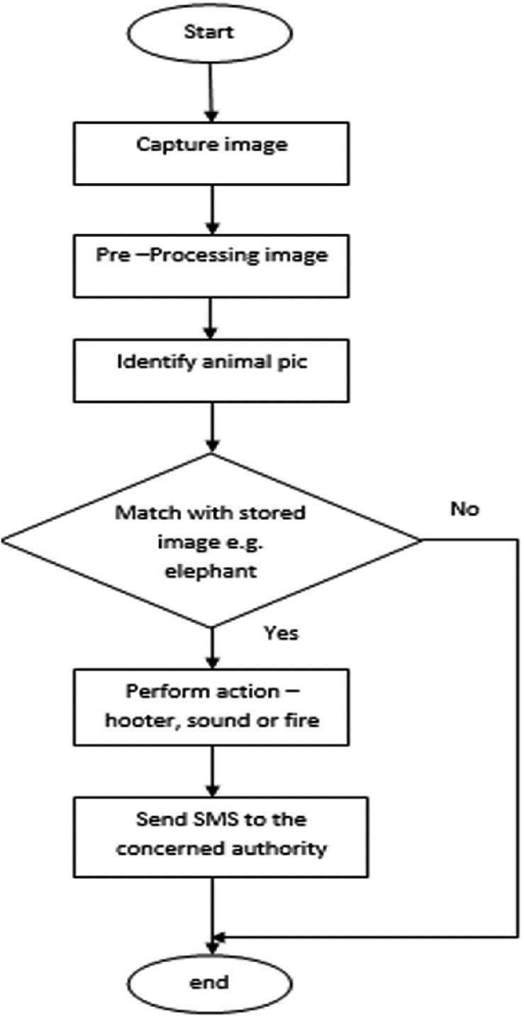

**Figure 2.12** Crop Protection System Against Wild Animals Attack

2.6.4 Result

In this paper, we presented an integrative approach in the field of Internet of Things for smart Agriculture based on Low power devices. For the development of crop protection system awareness is needed regarding the product among the people**.** GSM module sends message to the farmer to alert him. From this it is concluded that the design system is very useful and affordable to the farmer. The design system will not be dangerous to animal and human being, and it protects farm.

2.6.5 Drawback

The problem is so pronounced that sometimes farmers decide to leave the area barren due to these animal attacks.

2.7 Protection of Crops from Wild Animals Using Intelligent Surveillance System

International Journal of Research in Advent Technology (IJRAT) Vol. 9 Issue 05, April-2018

2.7.1 Introduction

Surveillance plays a major role in many fields be it at home, hospitals, schools, public places, farmlands etc. It helps us to monitor a certain area and prevent theft and also provides proof of evidence. Various methods aim only at surveillance which is mainly for human intruders, but we tend to forget that the main enemies of such farmers are the animals which destroy the crops. This leads to poor yield of crops and significant financial loss to the owners of the farmland. This problem is so pronounced that sometimes the farmers decide to leave the areas barren due to such frequent animal attacks. This system helps us to keep away such wild animals from the farmlands as well as provides surveillance functionality.

###### 2.7.2 Black Diagram

If the motion detection is due to an authorized person with a valid RFID, who is mostly a farm worker, his attendance gets recorded automatically.

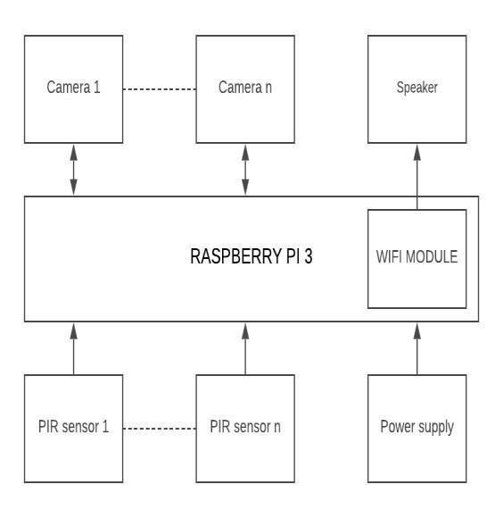

**Figure 2.13** Intelligent Surveillance System

The problem of crop vandalization by wild animals has become a major social problem in the current time. It requires urgent attention and an effective solution. Thus this project carries a great social relevance as it aims to address this problem. Hence we have designed a smart embedded farmland protection and surveillance based system which is low cost, and also consumes less energy. The main aim is to prevent the loss of crops and to protect the area from intruders and wild animals which pose a major threat to the agricultural areas. Such a system will be helpful to the farmers in protecting their orchards and fields and save them from significant financial losses and also saves them from unproductive efforts that they endure for the protection of their fields. This system will also help them in achieving better crop yields thus leading to their economic wellbeing

2.7.6 Flow chart

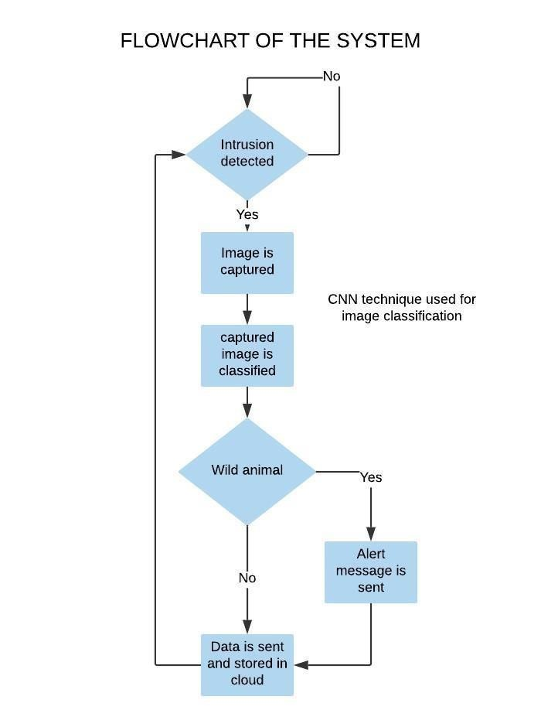

###### Figure 2.14 Intelligent Surveillance System

This flow chart explain about the Protection of Crops from Wild Animals Using Intelligent Surveillance System. There is a possibility of fire with electric fences when bushes or trees grow close to the fence. Therefore, keeping the electric fence region clean of any such crop is critical. The grounding must also be tested to ensure that the grounding is performed correctly or not. In that case, if it is not handled correctly, animal life will be endangered and it is therefore very risky for human beings. For producers, it would be too costly

This explain about the Protection of Crops from Wild Animals Using Intelligent Surveillance System. There is a possibility of fire with electric fences when bushes or trees grow close to the fence. Therefore, keeping the electric fence region clean of any such crop is critical. The grounding must also be tested to ensure that the grounding is performed correctly or not. In that case, if it is not handled correctly, animal life will be endangered and it is therefore very risky for human beings. For producers, it would be too costly.

2.7.4 Result

The problem of crop vandalization by wild animals has become a major social problem in the current time. It requires urgent attention and an effective solution. Thus this project carries a great social relevance as it aims to address this problem. Hence we have designed a smart embedded farmland protection and surveillance based system which is low cost, and also consumes less energy. The main aim is to prevent the loss of crops and to protect the area from intruders and wild animals which pose a major threat to the agricultural areas. Such a system will be helpful to the farmers in protecting their orchards and fields and save them from significant financial losses and also saves them from unproductive efforts that they endure for the protection of their fields. This system will also help them in achieving better crop yields thus leading to their economic wellbeing.

2.7.5 Drawback

There has been a surge in the demand of Internet of Things (IoT) in many sectors, which has drawn significant research attention from both the academia and the industry. Such a system will be helpful to the farmers in protecting their orchards and fields and save them from significant financial losses and also saves them from unproductive efforts that they endure for the protection of their fields.

2.8 Smart Irrigation And Crop Protection From Wild Animals

International Journal of Emerging Technologies in Engineering Research (IJETER) Volume 5, Issue 3, March (2020)

2.8.1 Introduction

India is a nation dependent upon agriculture. Improving the efficiency and quality of agro-based goods therefore is very critical. The design proposed is an automatic system which assists the farmer in the irrigation process. This project focuses on detecting wild animals along the farm's border and also saving water by switching on and off the motor based on soil moisture content. Here we use IR sensors to detect wild animals, soil moisture sensors to detect moisture content in the farm, some speakers to deliver some scary sounds so animals can be afraid to get into the field, and microcontrollers to collect sensor data. This project describes a security alarm system that can monitor an industry and home. This motion detector is realized using readily available, low cost components .One of its many applications is in a rolling shutter guard for offices, lands and shops. The detector will sense motion caused by activities like animals and switch on the connected load (bulb, piezo buzzer, etc) to alert you.

###### 2.8.2 Block diagram

which helps to switch the voltage. This project focuses on detecting wild animals along the farm's border and also saving water by switching on and off the motor based on soil moisture content. Here we use IR sensors to detect wild animals, soil moisture sensors to detect moisture content in the farm, some speakers to deliver some scary sounds so animals can be afraid to get into the field, and microcontrollers to collect sensor data. Agricultural sector faces many problems nowadays due to a lack of water resources. Smart irrigation system has been used to help the farmers resolve the difficulties. Different sensors such as soil moisture, DHT11, PIR (intruder detection network) are connected to Arduino microcontroller's input pins within this device. The sensed sensor values are displayed in LCD. If the sensed value exceeds the threshold values set in the system, the relay circuit automatically switches the pumpON / OFF and it is connected to the driver circuit Animal detection system is designed to detect the presence of animal and offer a warning. If the sensed value exceeds the threshold values set in the system, the relay circuit automatically switches the pumpON / OFF and it is connected to the driver circuit Animal detection system is designed to detect the presence of animal and offer a warning. This motion detector is realized using readily available, low cost components .One of its many applications is in a rolling shutter guard for offices, lands and shops. The detector will sense motion caused by activities like animals and switch on the connected load (bulb, piezo buzzer, etc) to alert you.

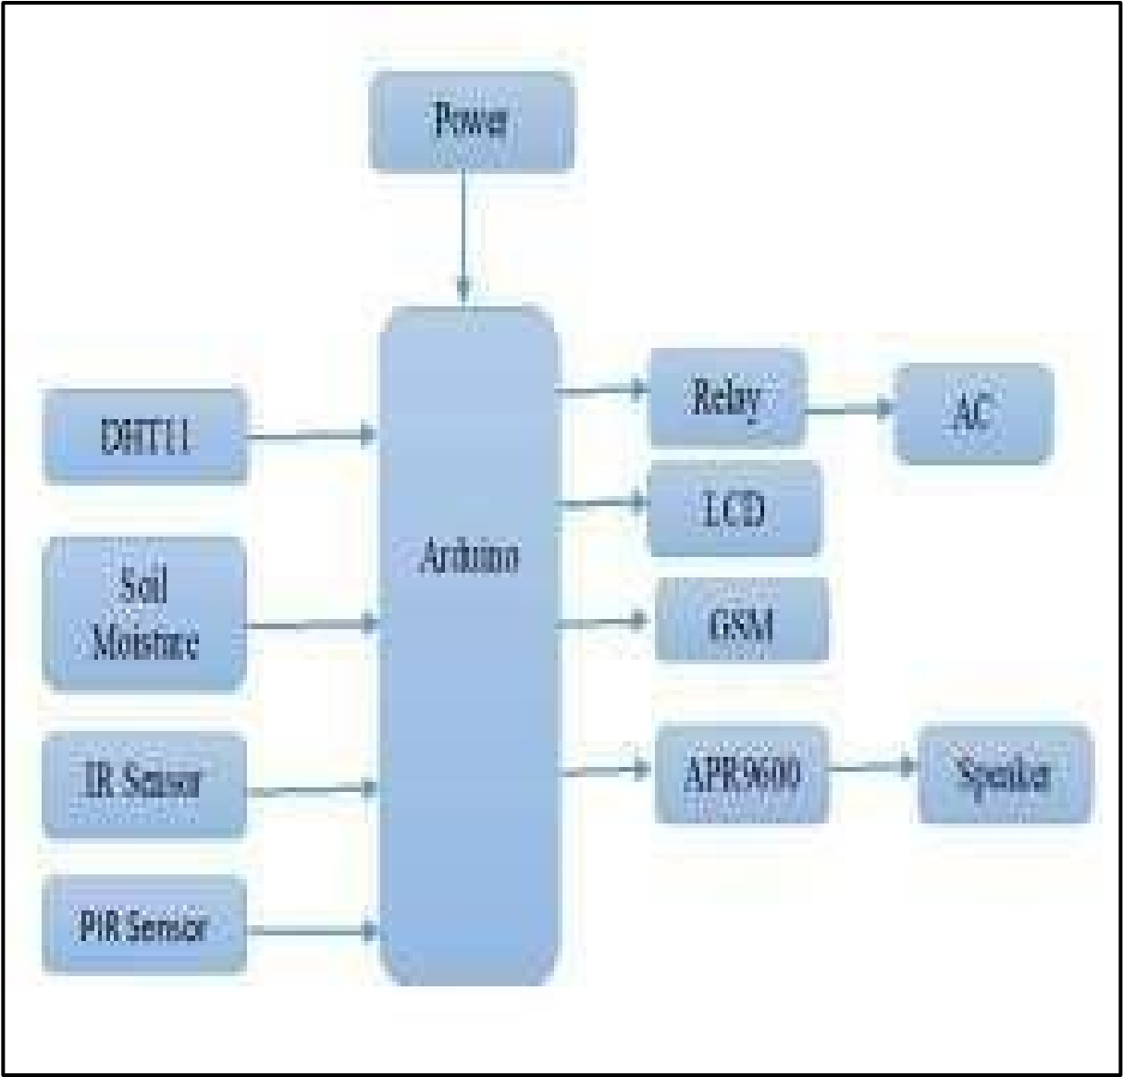

**Figure 2.15** Crop Protection From Wild Animals

###### 2.8.3 Flow chart

The proposed system uses an Arduino board which forms the main heart of the system, the different sensors and camera is interfaced to the board. As soon as the PIR sensors go High on detecting motion within a range of 10 meters, the camera will be turned ON which first captures an image and then starts recording the video for about five to six minutes, the camera will be turned ON which first captures an image and then starts recording the video for about five to six minutes. India is a nation dependent upon agriculture. Improving the efficiency and quality of agro-based goods therefore is very critical. The design proposed is an automatic system which assists the farmer in the irrigation process. This project focuses on detecting wild animals along the farm's border and also saving water by switching on and off the motor based on soil moisture content. Here we use IR sensors to detect wild animals, soil moisture sensors to detect moisture content in the farm, some speakers to deliver some scary sounds so animals can be afraid to get into the field, and microcontrollers to collect sensor data. This project describes a security alarm system that can monitor an industry and home. This motion detector is realized using readily available, low cost components .One of its many applications is in a rolling shutter guard for offices, lands and shops. The detector will sense motion caused by activities like animals and switch on the connected load (bulb, piezo buzzer, etc) to alert .

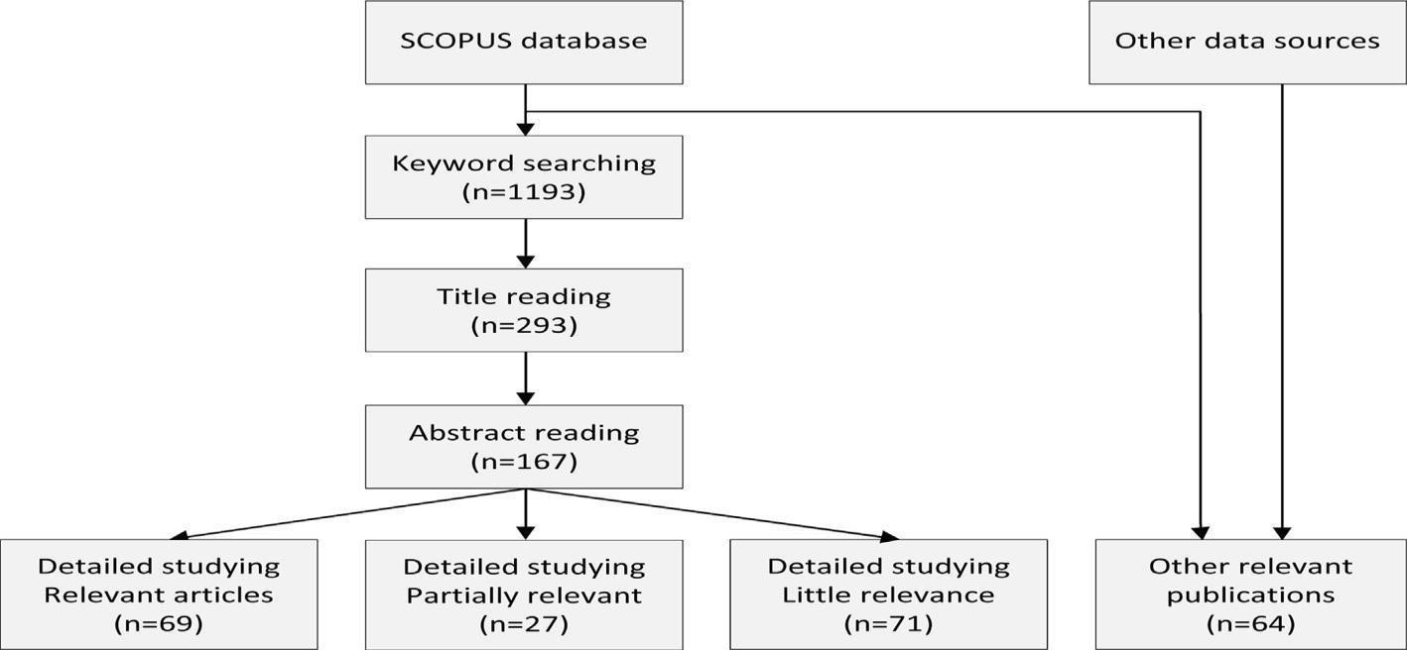

**Figure 2.16** Crop Protection From Wild Animals

###### 2.8.4 Result

The problem of crop destruction by wild animals has become a serious problem for the farmer. Effective solution and urgent attention are needed to solve this serious problem. To solve the problem of farmer we have designed a smart earlier detection and protection system with the help of IOT. Measuring four parameters such as soil moisture, temperature, humidity and the system also includes intruder detecting system.

###### 2.8.5 Drawback

This problem is so severe that due to such regular attacks on animals, the farmers often prefer to leave the areas barren. This system allows us to keep these wild animals away from the farmlands and also provides flexibility for surveillance

###### 2.9 Implementation of IoT Application using Geofencing Technology for Protecting

###### Crops from Wild Animals

International Research Journal of Engineering and Technology (IRJET), April2018

2.9.1 Introduction

In this paper, we propose a wild animal intrusion notification system using IoT and geofencing technology to protect crops from intruders such as wild animals. The system consists of an ultrasonic sensor to detect wild animals.This device can be controlled and monitored from remote location and it can be implemented in agricultural fields, grain stores and cold stores for security purpose. This paper is oriented to accentuate the methods to solve such problems like identification of rodents, threats to crops and delivering real time notification based on information analysis and processing without human intervention.

2.9.2 Block diagram

The proposed system, hardware modules, namely, an ultrasonic sensor, GPS module, and LTE module are connected, and the entire procedure is conducted using Arduino Uno Ultrasonic sensors and GPS module are used to detect targets The transmitted data are stored in the Firebase database and the notification about intrusion is provided to the farmer by the proposed mobile application Human- elephant conflict is more in south Asia and in Africa.

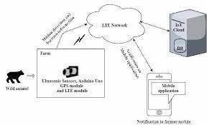

###### Figure 2.17 Application using Geofencing Technology

This is a simple and useful security system and easy to install. This motion detector is realized using readily available, low cost components. One of its many ap- plications is in a rolling shutter guard for offices, lands and shops. The detector will sense motion caused by activities like animals and switch on the connected load (bulb, piezo buzzer, etc) to alert you. Usually farms are protected with electrical fence to protect the crops from wild animals.

**2.9.3 Flow chart**

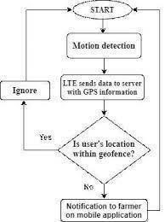

###### Figure 2.18 Application using Geofencing Technology

This project focuses on detecting wild animals along the farm's border and also saving water by switching on and off the motor based on soil moisture content. Here we use IR sensors to detect wild animals, soil moisture sensors to detect moisture content in the farm, some speakers to deliver some scary sounds so animals can be afraid to get into the field, and microcontrollers to collect sensor data. Agricultural sector faces many problems nowadays due to a lack of water resources. Smart irrigation system has been used to help the farmers resolve the difficulties. Different sensors such as soil moisture, DHT11, PIR (intruder detection network) are connected to Arduino microcontroller's input pins within this device. The sensed sensor values are displayed in LCD. If the sensed value exceeds the threshold values set in the system, the relay circuit automatically switches the pump ON / OFF and it is connected to the driver circuit Animal detection system is designed to detect the presence of animal and offer a warning.

LTE networks using mobile Internet connectivity are able to upload and download faster and essentially do anything on the web. However, there are also some limitations the LTE network cells are small. The proposed system uses an Arduino board which forms the main heart of the system, the different sensors and camera is interfaced to the board. As soon as the PIR sensors go High on detecting motion within a range of 10 meters, the camera will be turned ON which first captures an image and then starts recording the video for about five to six minutes, the camera will be turned ON which first captures an image and then starts recording the video for about five to six minutes.

2.9.4 Result

The mobile application uses cloud messaging to notify the farmer about intrusions. When an intrusion is detected in the farm field, the application receives a notification, as displayed . By clicking on the message, the farmer can see the location as well as the distance of the intruder from the sensor, as displayed in Fig. The mobile application provides the feature of warning the farmer beforehand by informing them about the intruder being at an appropriate location before intrusion into the farm field. The proposed system uses an Arduino board which forms the main heart of the system, the different sensors and camera is interfaced to the board.

2.9.5 Drawback

The wireless sensor network for the protection of crops from wild animals. Wild animals also damage standing crops, which adversely affect annual crop growth, resulting in financial losses for farmers.

2.10 Fire Detection and Prevention in Agriculture Field Using IoT

Journal of Xi'an University of Architecture & Technology ISSN No : 10067930

2.10.1 Introduction

Fire is an unexpected event that causes a huge loss for farmers. Agricultural fields in Delhi, Haryana, and the border of Punjab are highly on alert during summer. The proposed system is divided into different subsystems named as FDS (Fire detection system) for fire detection, FPS (Fire prevention system) using servo motor along with a pump, which runs continuously without fail or any intervention. When a fire is detected the automated system triggers only if no action is taken by the user for the given timestamp. The model continuously examines the sensor data coming from the field and stores the data in Firebase than analyzing the data based on the algorithm and prevent the fire before it spreads in the field using a mobile application. In this perspective, a system to detect fire and alarm the employees before it breaks out is a crying need. Ensuring minimum rights and safety of the garment workers has become a burning issue nowadays. The workers of garment factories are facing broken out of fire is surely one of them. . There isnt anyone at the garment factory and a fire breaks out. This will not only cause loss for the investors but also there would not be any data available to investigate cause & claim any insurance. In this paper, we designed an IoT based fire alarming system to help detect fire as soon as possible & take immediate precaution using water pump used as well as send email to owner & SMS to nearest fire station & save precious human lives.This will not only cause loss for the investors but also there would not be any data available to investigate cause & claim any insurance. In this paper, we designed an IoT based fire alarming system to help detect fire as soon as possible & take immediate precaution using water pump used as well as send email to owner & SMS to nearest fire station & save precious human lives. In this paper, we designed an IoT based fire alarming system to help detect fire as soon as possible & take immediate precaution using water pump used as well as send email.

2.10.2 Block diagram

The proposed system has an early prototype for fire detection and prevention models for farmers to use. Fire Prevention System (FPS) is the extended operation the system is capable of performing after the fire is detected. FPS uses a servo motor and pumps to rotate and pour water at the origin of the fire. If the user doesn’t take necessary actions to put of the fire within defined timestamp, the water from the sprinkler system spreads automatically in the detected area of the field.

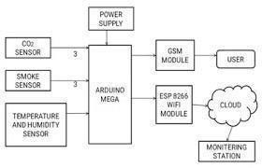

###### Figure 2.19 Prevention in Agriculture Field Using IoT

Continuous reading of data from the field helps in regular monitoring and gives a better reliable system with cost-efficiency. The following modules are used for both the system depending on which the required actions are taken. The sensors sense the data if getting values is above the threshold value the fire alarm gets ON. If fire is occurs then water pump & buzzer gets ON. If gas is detected only buzzer gets ON. All these information send to raspberry pi & it capture images, upload into webpage, SMS & mail send to owner & fire station. The camera Module can rotate 360Â° by using a servo motor. After this condition is true the fire alarm will trigger by the help of the Relay module. LCD monitoring all the thing where the system is working properly or not. It give an update step by step. PIR sensor can be placed for any unknown person is found at authorized place. The proposed system has an early prototype for fire detection and prevention models for farmers to use. The whole system can be classified into two different sections named as Fire Detection System (FDS) and Fire Prevention System (FPS).

2.10.3 Flow chart

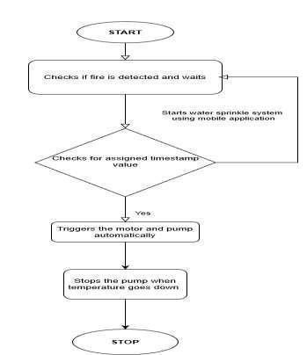

**Figure 2.20** Prevention in Agriculture Field Using IoT

When a fire is detected the next step taken from the system is to prevent the fire by using two means, first is to send the alert and option . Second is the automated system which comes in play after a certain timestamp is crossed and no action has been performed, the system is capable of automatically start the water sprinkle system after the timestamp is crossed in the detected area so that the fire can be stopped from the origin before it spreads. FPS uses servo motor and pumps water when the fire is detected the motor turns the pump to the detected location and starts spraying water. The system efficiently pours water with the proper amount depending on the fire and closes the pump when the fire has stopped. This prevents the extra water wastage as the system is precise and can be used for other purposes. Second is the automated system which comes in play after a certain timestamp is crossed and no action has been performed, the system is capable of automatically start the water sprinkle system after the timestamp is crossed in the detected area so that the fire can be stopped from the origin before it spreads. FPS uses servo motor and pumps water when the fire is detected the motor turns the pump to the detected location and starts spraying water.

2.10.4 Result

For this evaluation, an experimental environment of agricultural field is set up using different sensor attached to Arduino Uno connected a 12V battery for power supply along with servo motor and pump. Arduino software platform is use to perform the experiment. The PC for experiment is equipped with an Intel P4 2.4GHz Personal laptop and 2GB memory. The proposed scheme is tested using data processing Algorithm. From the simulation of the experiment results, we can draw to the conclusion that this method is robust to different situations..

2.10.5 Drawback

Indian agriculture is often affected due to various changes such as weather, water scarcity, and natural disasters. Fire is one of the unpredicted and unknown events that harm the productivity of a farmer.

**CHAPTER 3**

### THEORETICAL BACKGROUND

#### 3.1 Existing System

Traditional electric fence has been helpful as a guard of crops. However, that system has some problems such as it cannot notify the voltage which occasionally drops. Furthermore, the owners of the fence have to check the voltage but they cannot know it without going there .An electric fence management system we develop uses wireless communication, and it enables the owners to know the voltage and the state of the electric fence and monitor it from remote locations safely. It describes a demonstrative experiment in a mountainous region, and suggests an approach to resolve some problems.

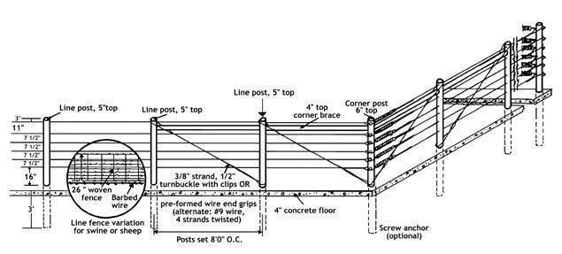

**Figure 3.1** Diagram of Electric fence

An electric fence system using wireless network technology has been developed. The system consists of several observers and a display , the farmers are able to measure voltage at the fence, and have an ability to show it. The observers transmit the voltage with the direction of the voltage leak to the display. Here we are using 2*16 display, The display shows the received data and the owners can know the state of the electric fence. Our main purpose of project is to develop intruder alert to the farm, to avoid losses due to animals and fire. These intruder alert protect the crop from damaging that indirectly increase yield of the crop. The develop system will not harmful and injurious to animal as well as human beings. Theme of project is to design a intelligent security system for farm protection by using Embedded system based arudino as shown in Animal attacks in India are a common story nowadays. Due to the unavailability of any detection system these attacks kill villagers and also destroy their crops .

#### 3.2 Proposed System

The main aim of our project is to protect the crops from damage caused by animal as well as divert the animal without any harm. Animal detection system is designed to detect the presence of animal and offer a warning. Agricultural sector faces many problems nowadays due to a lack of water resources. Smart irrigation system has been used to help the farmers resolve the difficulties. Different sensors such as soil moisture, DHT11, PIR (intruder detection network) are connected to Arduino microcontroller's input pins within this device. The sensed sensor values are displayed in LCD. If the sensed value exceeds the threshold values set in the system, the relay circuit automatically switches the pump ON / OFF and it is connected to the driver circuit which helps to switch the voltage. The farmer will be intimated via GSM module about the current condition of the field. By using this device, the farmer can at any time access the details of the field condition anywhere. Animal detection system is designed to detect the presence of animal and offer a warning.

In this project we used PIR and ultrasonic sensors to detect the movement of the animal and send signal to the controller. It diverts the animal by producing sound and signal further, this signal is transmitted to GSM and which gives an alert to farmers and forest department immediately. Arduino boards are able to read analog or digital input signals from different sensors and turn it into an output such as activating a motor, turning LED on/off, connect to the cloud and many other actions. We can control our board functions by sending a set of instructions to the microcontroller on the board via Arduino IDE. Here aurdino is used to collect the data from the sensors such PIR motion sensor, IR Sensor and Soil Moisture Sensor. Finally, the alarm part consists of a GSM module which makes a call to the farmer and speaker which produces sound to scare the animals. . Arduino boards are able to read analog or digital input signals from different sensors and turn it into an output such as activating a motor, turning LED on/off, connect to the cloud and many other actions.

**3.2.1 Introduction**

In the world, the economy of many countries is dependent upon agriculture. In spite of economic development agriculture is the backbone of the economy. Agriculture is the main stay of economy. It contributes to the gross domestic product. Agriculture meets food requirements of the people and produces several raw materials for industries. But because of animal interference and fire in agricultural lands, there will be huge loss of crops. Crop will be totally getting destroyed. There will be large amount of loss of farmer. To avoid these financial losses it is very important to protect agricultural field or farms from animal and fire. To overcome this problem, in our proposed work we shall design a system to prevent the entry of animals into the farm. The concept of IoT was introduced by a member of RFID development community in the year 1999. After it became more famous to the practical world because of rapid growth in mobile devices, embedded systems, cloud computing, ubiquitous computing and data analytics. In several areas, surveillance plays a major role, be it at home, hospitals, schools, public places, farmlands, etc. This lets us track a certain area and prevent fraud, and also provides evidence in the event of these incidents happening. Surveillance of farmlands or agricultural land is very important in order to prevent unauthorized persons from gaining access to the field and also to protect the field from animals.

Different strategies aim only at surveillance that is mainly for human intruders, but we appear to overlook that the biggest enemies of these farmers are the animals that eat the crops. In the states of Tamil Nadu, Himachal Pradesh, Punjab, Haryana, Kerala and many other states, the issue of wildlife attack on crops i.e. crop vandalization is becoming very common. Wild animals such as monkeys, elephants, wild pigs, deer’s, wild dogs, bison, nilgais, feral animals such as cows and buffaloes and even birds such as parakeets do a lot of harm to crops by running over them, eating them and vandalizing them entirely. This leads to low crop yield and substantial financial loss for farmland owners. This problem is so severe that due to such regular attacks on animals, the farmers often prefer to leave the areas barren. This system allows us to keep these wild animals away from the farmlands and also provides flexibility for surveillance. It was found that the smell of rotten egg helps prevent the wild pigs and deers from eating the crops, so farmers spray the rotten egg solution manually on their fields, and firecrackers are used to fend off the wild elephants that eat the crops. Depending on the need, the system is automated so there is no manual labor, thus saving time and also avoiding crop loss. If the motion detection is due to an authorized person with a valid RFID, who is mostly a farm worker, his attendance gets recorded automatically. Whereas if the motion detection is due to that of an unauthorized person without the valid RFID tag, the system further.

**3.2.2 Technique**

As soon as the motion sensors go High on detecting motion within a range of 10 meters, the camera will be turned ON which first captures an image and then starts recording the video for about five to six minutes, which will be stored on board as well as cloud, simultaneously a message will be generated automatically to the registered number using a SIM900A module to inform about the intrusion along with the details of the temperature and humidity obtained by interfacing dht11 temperature and humidity sensor. If the motion detection is due to an authorized person with a valid RFID, who is mostly a farm worker, his attendance gets recorded automatically. Whereas if the motion detection is due to that of an unauthorized person without the valid RFID tag, the system further processes the image and video using feature based Cascade Classifiers for object detection, and decides if the entity is an animal or human intruder.

###### 3.2.3 Block Diagram

In this project we used Laser and to detect the movement of the animal and send signal to the controller .It diverts the animal by producing sound by using fig 8 Buzzer and the signal ,this signal is transmitted to GSM and which gives an SMS alert to farmers . And fig4 smoke sensor is used to detect fire in the form and DC motor is used to generate the signal it is consists of a 3v LCD display is displays the receiving data. Here we are using step-down power supply 230 .Thus this project carries a great social relevance as it aims to address this problem.

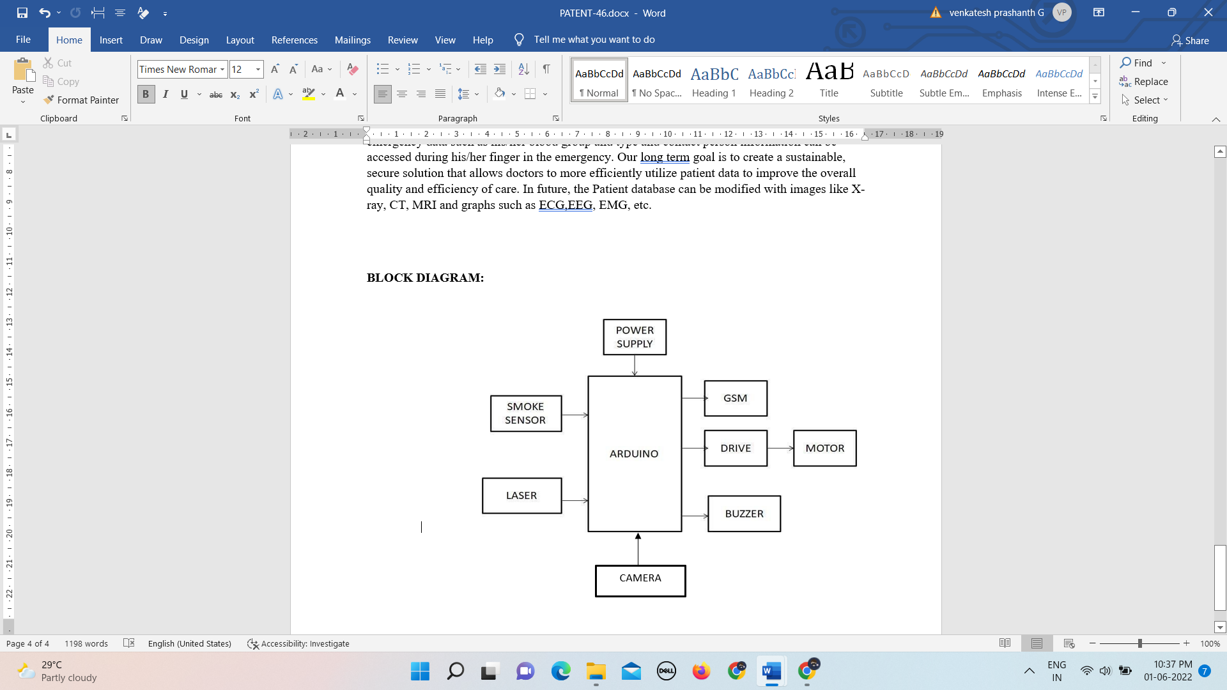

**Figure 3.2** Electric fence

###### 3.2.4 Flow Chart

In this project we used Laser and to detect the movement of the animal and send signal to the controller .It diverts the animal by producing sound by using fig 8 Buzzer and the signal ,this signal is transmitted to GSM and which gives an SMS alert to farmers . And fig4 smoke sensor is used to detect fire in the form and DC motor is used to generate the signal it is consists of a 3v LCD display is displays the receiving data. Here we are using step-down power supply 230 .Thus this project carries a great social relevance as it aims to address this problem. This project will help farmers in protecting their orchards and fields and save them from significant financial losses and will save them from the unproductive efforts that they endure for the protection their fields. This will also help them in achieving better crop yields thus leading to their economic wellbeing.

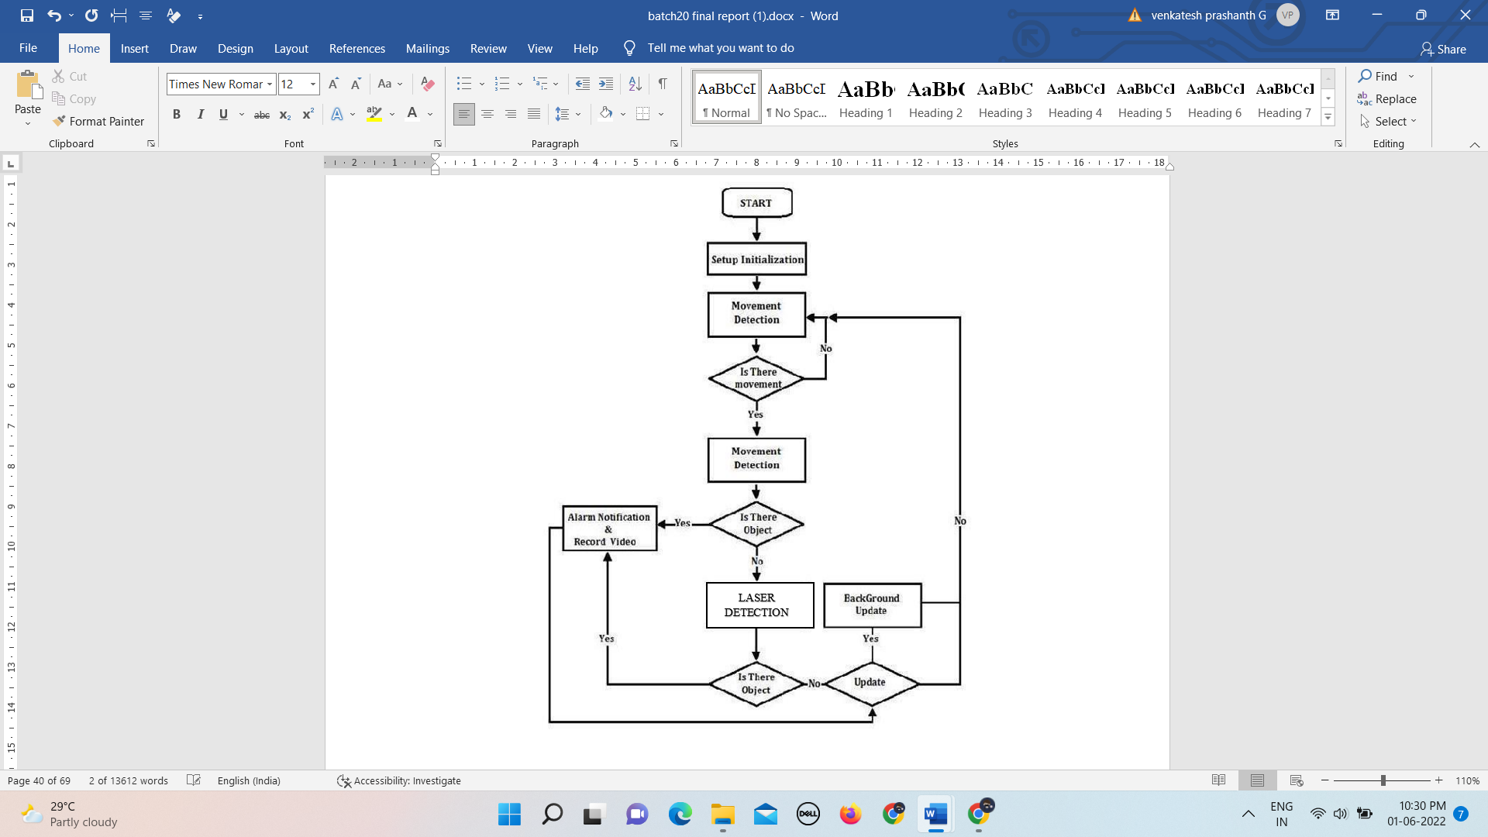

**Figure 3.3** Flow Chart

The implemented system can detect the fire from the origin and send an alert very effective manner. The automated system for water sprinkling also works efficiently parallel by using the algorithm. The android application notifies the user/farmer on the regular status of the field and also sends an alert notification when a fire is detected. The application activates the water sprinkle system for the user/farmer on a press button. For future reference work, the existing sensors can be replaced with industry grade sensors to increase the efficiency of the system

#### SYSTEM SPECIFICATION

##### 4.1 Hardware Description

* Arduino mega Microcontroller
* Laser
* Relay
* LCD
* Power Supply
* GSM
* Buzzer
* DC Motor
* Smoke Sensor

##### 4.1.1 Arduino mega

Arduino is a computer hardware and software company, project, and user community that designs and manufactures [microcontroller kit](https://en.wikipedia.org/wiki/Microcontroller)s for building digital devices and interactive objects that can sense and control objects in the physical world. The project's products are distributed as [open-source hardware and](https://en.wikipedia.org/wiki/Open-source_hardware) [software, wh](https://en.wikipedia.org/wiki/Open-source_software)ich are licensed under the [GNU Lesser General Public License (LG](https://en.wikipedia.org/wiki/GNU_Lesser_General_Public_License)PL) or the [GNU General Public License (GP](https://en.wikipedia.org/wiki/GNU_General_Public_License)L), permitting the manufacture of Arduino boards and software distribution by anyone. Arduino boards are available commercially in preassembled form, or as [do-it-yourself kit](https://en.wikipedia.org/wiki/Do-it-yourself)s. The project's board designs use a variety of microprocessors and controllers. These systems provide sets of digital and analog [input/output (I/](https://en.wikipedia.org/wiki/Input/output)O) pins that may be interfaced to various expansion boards ("shields") and other circuits. The boards feature serial communications interfaces, including Universal Serial Bus ([USB) on](https://en.wikipedia.org/wiki/USB) some models, for loading programs from personal computers. The microcontrollers are mainly programmed using a dialect of features from the programming languages [C and](https://en.wikipedia.org/wiki/C_%28programming_language%29) [C++. In](https://en.wikipedia.org/wiki/C%2B%2B) addition to using traditional compiler toolchains, the Arduino project provides an [integrated development environment (ID](https://en.wikipedia.org/wiki/Integrated_development_environment)E) based on the [Processing lan](https://en.wikipedia.org/wiki/Processing_%28programming_language%29)guage project. The Arduino project started in 2005 as a program for students at th[e Interaction Design Institute Ivrea i](https://en.wikipedia.org/wiki/Interaction_Design_Institute_Ivrea)[n Ivrea, It](https://en.wikipedia.org/wiki/Ivrea)aly, aiming to provide a low-cost and Common examples of such devices intended for beginner hobbyists include simple [robo](https://en.wikipedia.org/wiki/Robot)[ts, thermostats, an](https://en.wikipedia.org/wiki/Thermostat)d [motion detectors.](https://en.wikipedia.org/wiki/Motion_detector)

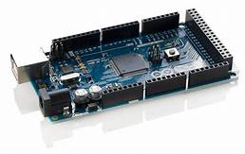

#### Figure 4.1 Arduino mega

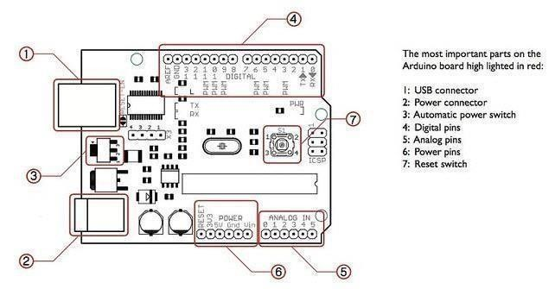

##### Figure 4.2 Uno R3 Microcontroller

###### 4.1.1.1 Specifications

* Microcontroller: ATmega328
* Operating Voltage: 5V
* Input Voltage (recommended): 7-12V
* Input Voltage (limits): 6-20V
* Digital I/O Pins:14(of which 6 provide PWM output)
* Analog Input Pins: 6

**Table 4.1** Specifications

|  |  |
| --- | --- |
| Microcontroller | [ATmega328P](http://www.atmel.com/Images/Atmel-42735-8-bit-AVR-Microcontroller-ATmega328-328P_Datasheet.pdf) |
| Operating Voltage | 5V |
| Input Voltage (recommended) | 7-12V |
| Input Voltage (limit) | 6-20V |
| Digital I/O Pins | 14 (of which 6 provide PWM output) |
| PWM Digital I/O Pins | 6 |
| Analog Input Pins | 6 |
| DC Current per I/O Pin | 20 mA |
| DC Current for 3.3V Pin | 50 mA |
| Flash Memory | 32 KB (ATmega328P) of which 0.5 KB used by bootloader |
| SRAM | 2 KB (ATmega328P) |
| EEPROM | 1 KB (ATmega328P) |
| Clock Speed | 16 MHz |
| LED_BUILTIN | 13 |
| Length | 68.6 mm |
| Width | 53.4 mm |
| Weight | 25 g |

###### 4.1.1.2 Power

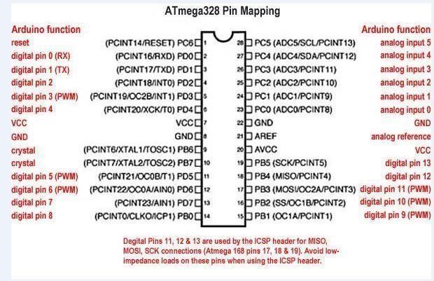

##### Figure 4.3 ATmega328 Pin Mapping

The Arduino Uno can be powered via the USB connection or with an external power supply. The power source is selected automatically. External (non-USB) power can come either from an AC-to-DC adapter (wall-wart) or battery. The adapter can be connected by plugging a 2.1mm centre-positive plug into the board's power jack. Leads from a battery can be inserted in the GND and Vin pin headers of the POWER connector. The board can operate on an external supply of 6 to 20 volts. If supplied with less than 7V, however, the 5V pin may supply less than five volts and the board may be unstable. If using more than 12V, the voltage regulator may overheat and damage the board. The recommended range is 7 to 12 volts.

###### 4.1.1.3 Input and Output

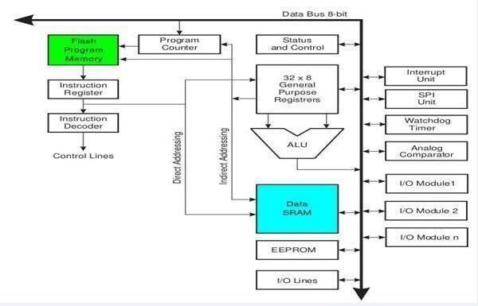

**Figure 4.4** Block Diagram

###### 4.1.1.4 Communication

The Arduino Uno has a number of facilities for communicating with a computer, another Arduino, or other microcontrollers. The ATmega328 provides UART TTL (5V) serial communication, which is available on digital pins 0 (RX) and 1 (TX). An ATmega8U2 on the board channels this serial communication over USB and appears as a virtual com port to software on the computer. The '8U2 firmware uses the standard USB COM drivers, and no external driver is needed. However, on Windows, a .inf file is required. The Arduino software includes a serial monitor which allows simple textual data to be sent to and from the Arduino board. The RX and TX LEDs on the board will flash when data is being transmitted via the USB-to-serial chip and USB connection to the computer (but not for serial communication on pins 0 and 1). A Software Serial library allows for serial communication on any of the Uno's digital pins. The ATmega328 also supports I2C (TWI) and SPI communication. The Arduino software includes a Wire library to simplify use of the I2C bus; see the documentation for details. For SPI communication, use the SPI library.

###### 4.1.1.5 Programming

The Arduino Uno can be programmed with the Arduino software. Select "Arduino Uno from the Tools > Board menu (according to the microcontroller on your board). For details, see the reference and tutorials. The ATmega328 on the Arduino Uno comes preburned with a boot loader that allows you to upload new code to it without the use of an external hardware programmer. It communicates using the original STK500 protocol (reference, C header files). You can also bypass the boot loader and program the microcontroller through the ICSP (In-Circuit Serial Programming) header; see these instructions for details. The ATmega8U2 firmware source code is available . The ATmega8U2 is loaded with a DFU boot loader, which can be activated by connecting the solder jumper on the back of the board (near the map of Italy) and then resetting the 8U2. You can then use Atmel's FLIP software (Windows) or the DFU programmer (Mac OS X and Linux) to load a new firmware. Or you can use the ISP header with an external programmer (overwriting the DFU boot loader). See this user-contributed tutorial for more information.

###### 4.1.1.6.Automatic (Software) Reset

Rather than requiring a physical press of the reset button before an upload, the Arduino Uno is designed in a way that allows it to be reset by software running on a connected computer. One of the hardware flow control lines (DTR) of the ATmega8U2 is connected to the reset line of the ATmega328 via a 100 nanofarad capacitor. When this line is asserted (taken low), the reset line drops long enough to reset the chip. The Arduino software uses this capability to allow you to upload code by simply pressing the upload button in the Arduino environment. This means that the boot loader can have a shorter timeout, as the lowering of DTR can be well-coordinated with the start of the upload. This setup has other implications. When the Uno is connected to either a computer running Mac OS X or Linux, it resets each time a connection is made to it from software (via USB). For the following half second or so, the boot loader is running on the Uno. While it is programmed to ignore malformed data (i.e. anything besides an upload of new code), it will intercept the first few bytes of data sent to the board after a connection is opened. If a sketch running on the board receives one-time configuration or other data when it first starts, make sure that the software with which it communicates waits a second after opening the connection and before sending this data. The Uno contains a trace that can be cut to disable the auto-reset. The pads on either side of the trace can be soldered together to re-enable it. It's labelled "RESET-EN". You may also be able to disable the auto-reset by connecting a 110 ohm resistor from 5V to the reset line; see this forum thread for details.

**4.1.2 Light Amplification by Stimulated Emission of Radiation** (**LASER**)

It is a mechanism for emitting [electromagnetic radiation](http://en.wikipedia.org/wiki/Electromagnetic_radiation), typically [light](http://en.wikipedia.org/wiki/Light) or [visible light](http://en.wikipedia.org/wiki/Visible_light), via the process of [stimulated emission](http://en.wikipedia.org/wiki/Stimulated_emission). The emitted laser light is (usually) a spatially [coherent](http://en.wikipedia.org/wiki/Coherence_%28physics%29), narrow [low-divergence beam](http://en.wikipedia.org/wiki/Beam_divergence), that can be manipulated with [lenses](http://en.wikipedia.org/wiki/Lens_%28optics%29). In laser technology, "coherent light" denotes a light source that produces (emits) light of in-step waves of identical frequency, phase,[[1]](http://en.wikipedia.org/wiki/Laser#cite_note-0) and polarization. The laser's beam of coherent light differentiates it from light sources that emit incoherent light beams, of random [phase](http://en.wikipedia.org/wiki/Phase_%28waves%29) varying with time and position. Laser light is generally a narrow-[wavelength](http://en.wikipedia.org/wiki/Wavelength) [electromagnetic spectrum](http://en.wikipedia.org/wiki/Electromagnetic_spectrum) monochromatic light; yet, there are lasers that emit a broad spectrum of light, or emit different wavelengths of light simultaneously.

|  |
| --- |
|  |

**4.1.2.1 Terminology**

[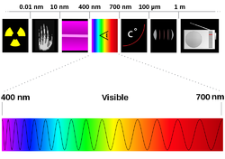](http://en.wikipedia.org/wiki/File:1000px-Spectre_visible_light.svg_fixed.png)

**Figure 4.5** Terminology

From left to right: [gamma rays](http://en.wikipedia.org/wiki/Gamma_rays), [X-rays](http://en.wikipedia.org/wiki/X-rays), [ultraviolet](http://en.wikipedia.org/wiki/Ultraviolet) rays, [visible spectrum](http://en.wikipedia.org/wiki/Visible_spectrum), [infrared](http://en.wikipedia.org/wiki/Infrared), [microwaves](http://en.wikipedia.org/wiki/Microwaves), [radio waves](http://en.wikipedia.org/wiki/Radio_waves).The word laser originally was the upper-case LASER, the [acronym](http://en.wikipedia.org/wiki/Acronym) from Light Amplification by Stimulated Emission of Radiation, wherein light broadly denotes [electromagnetic radiation](http://en.wikipedia.org/wiki/Electromagnetic_radiation) of any frequency, not only the [visible spectrum](http://en.wikipedia.org/wiki/Visible_spectrum); hence [infrared](http://en.wikipedia.org/wiki/Infrared) laser, [ultraviolet](http://en.wikipedia.org/wiki/Ultraviolet) laser, [X-ray](http://en.wikipedia.org/wiki/X-ray) laser, et caetera. Because the microwave predecessor of the laser, the [maser](http://en.wikipedia.org/wiki/Maser), was developed first, devices that emit [microwave](http://en.wikipedia.org/wiki/Microwave) and [radio](http://en.wikipedia.org/wiki/Radio_frequency) frequencies are denoted “masers”. In the early technical literature, especially in that of the [Bell Telephone Laboratories](http://en.wikipedia.org/wiki/Bell_Telephone_Laboratories) researchers, the laser was also called optical maser, a currently uncommon term; moreover, since 1998, Bell Laboratories adopted the laser usage.[[2]](http://en.wikipedia.org/wiki/Laser#cite_note-1) Linguistically, the [back-formation](http://en.wikipedia.org/wiki/Back-formation) verb to lase means “to produce laser light” and “to apply laser light to”.[[3]](http://en.wikipedia.org/wiki/Laser#cite_note-2) The word *laser* sometimes is used in an extended sense to describe a non-laser-light technology, e.g. a coherent-state atom source is an [atom laser](http://en.wikipedia.org/wiki/Atom_laser).

**4.1.2.2 Design**

Principal components:  
1. Gain medium  
2. Laser pumping energy  
3. High reflector  
4. [Output coupler](http://en.wikipedia.org/wiki/Output_coupler)  
5. Laser beam

[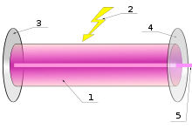](http://en.wikipedia.org/wiki/File:Laser.svg)

**Figure 4.6** Laser

###### 4.1.3 Relay

A relay is an [electrically ope](http://en.wikipedia.org/wiki/Electric)rated [switch. Ma](http://en.wikipedia.org/wiki/Switch)ny relays use an [electromagnet to](http://en.wikipedia.org/wiki/Electromagnet) operate a switching mechanism mechanically, but other operating principles are also used. Relays are used where it is necessary to control a circuit by a low-power signal (with complete electrical isolation between control and controlled circuits), or where several circuits must be controlled by one signal. The first relays were used in long distance telegraph circuits, repeating the signal coming in from one circuit and retransmitting it to another. Relays were used extensively in telephone exchanges and early computers to perform logical operations.

A type of relay that can handle the high power required to directly control an electric motor or other loads is called a [contact](http://en.wikipedia.org/wiki/Contactor)[or. Solid-state relays con](http://en.wikipedia.org/wiki/Solid-state_relay)trol power circuits with no [moving parts, in](http://en.wikipedia.org/wiki/Moving_parts)stead using a semiconductor device to perform switching. Relays with calibrated operating characteristics and sometimes multiple operating coils are used to protect electrical circuits from overload or faults; in modern electric power systems these functions are performed by digital instruments still called "[protective relays". w](http://en.wikipedia.org/wiki/Protective_relay)here it is necessary to control a circuit by a low-power signal (with complete electrical isolation), or where several circuits must be controlled by one signal. Solid-state relays control power circuits with no [moving parts, in](http://en.wikipedia.org/wiki/Moving_parts)stead using a semiconductor device to perform switching.

4.1.3.1 Basic Design And Operation

A simple electromagnetic relay consists of a [coil of](http://en.wikipedia.org/wiki/Coil) wire wrapped around a [soft iron core, an](http://en.wikipedia.org/wiki/Magnetic_core) iron yoke which provides a low [reluctance pat](http://en.wikipedia.org/wiki/Magnetic_reluctance)h for magnetic flux, a movable iron [armature, an](http://en.wikipedia.org/wiki/Armature_%28electrical_engineering%29)d one or more sets of contacts (there are two in the relay pictured). The armature is hinged to the yoke and mechanically linked to one or more sets of moving contacts. It is held in place by a [spring so](http://en.wikipedia.org/wiki/Spring_%28device%29) that when the relay is de-energized there is an air gap in the magnetic circuit. In this condition, one of the two sets of contacts in the relay pictured is closed, and the other set is open. Other relays may have more or fewer sets of contacts depending on their function. The relay in the picture also has a wire connecting the armature to the yoke. This ensures continuity of the circuit between the moving contacts on the armature, and the circuit track on the [printed circuit board (PC](http://en.wikipedia.org/wiki/Printed_circuit_board)B) via the yoke, which is soldered to the PCB.

4.1.3.2 Application

Relays are used for:

* Amplifying a digital signal, switching a large amount of power with a small operating
* Detecting and isolating faults on transmission and distribution lines by opening
* Vehicle battery isolation. A 12v relay is often used to isolate any second battery .
* Switching to a standby power supply.

###### 4.1.4 LCD

A liquid crystal display (LCD) is a flat panel display, electronic visual display, or video display that uses the light modulating properties of liquid crystals. Liquid crystals do not emit light directly. LCDs are available to display arbitrary images (as in a generalpurpose computer display) or fixed images which can be displayed or hidden, such as preset words, digits, and 7-segment displays as in a digital clock. They are common in consumer devices such as video players, gaming devices, clocks, watches, calculators, and t 4.elephones, and have replaced cathode ray tube (CRT) displays in most applications. They are available in a wider range of screen sizes than CRT and plasma displays, and since they do not use phosphors, they do not suffer image burn-in. LCDs are, however, susceptible to image persistence.

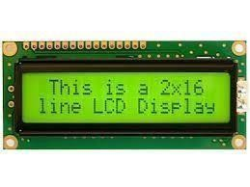

#### Figure 4. 7 LCD

##### 4.1.4.1 16x2 LCD

A 16x2 LCD means it can display 16 characters per line and there are 2 such lines. In this LCD each character is displayed in 5x7 pixel matrix. This LCD has two registers, namely, Command and Data. The command register stores the command instructions given to the LCD

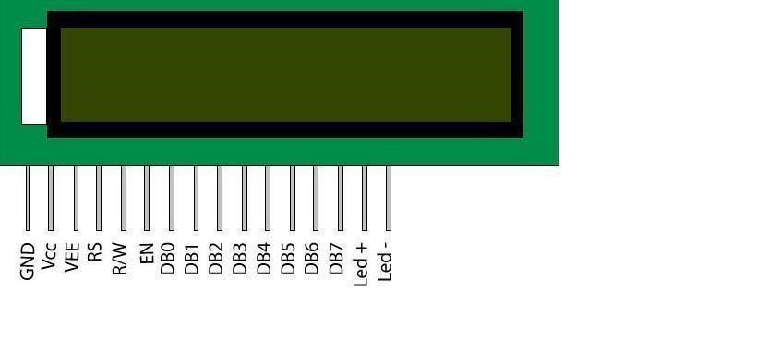

#### Figure 4.8 16x2 LCD

A command is an instruction given to LCD to do a predefined task like initializing it, clearing its screen, setting the cursor position, controlling display etc. The data register stores the data to be displayed on the LCD. The data is the ASCII value of the character to be displayed on the LCD. Click to learn more about internal structure of a [LCD.](http://www.engineersgarage.com/insight/how-lcd-works)

##### 4.1.4.2 Pin Description

Arduino is a computer hardware and software company, project, and user community that designs and manufactures [microcontroller kit](https://en.wikipedia.org/wiki/Microcontroller)s for building digital. control objects in the physical world. The project's products are distributed as [open-source hardware and](https://en.wikipedia.org/wiki/Open-source_hardware) [software, wh](https://en.wikipedia.org/wiki/Open-source_software)ich are licensed under the [GNU Lesser General Public License (LG](https://en.wikipedia.org/wiki/GNU_Lesser_General_Public_License)PL) or the [GNU General Public License (GP](https://en.wikipedia.org/wiki/GNU_General_Public_License)L), permitting the manufacture of Arduino boards and software distribution by anyone. Arduino boards are available commercially in preassembled form, or as [do-it-yourself kit](https://en.wikipedia.org/wiki/Do-it-yourself)s.

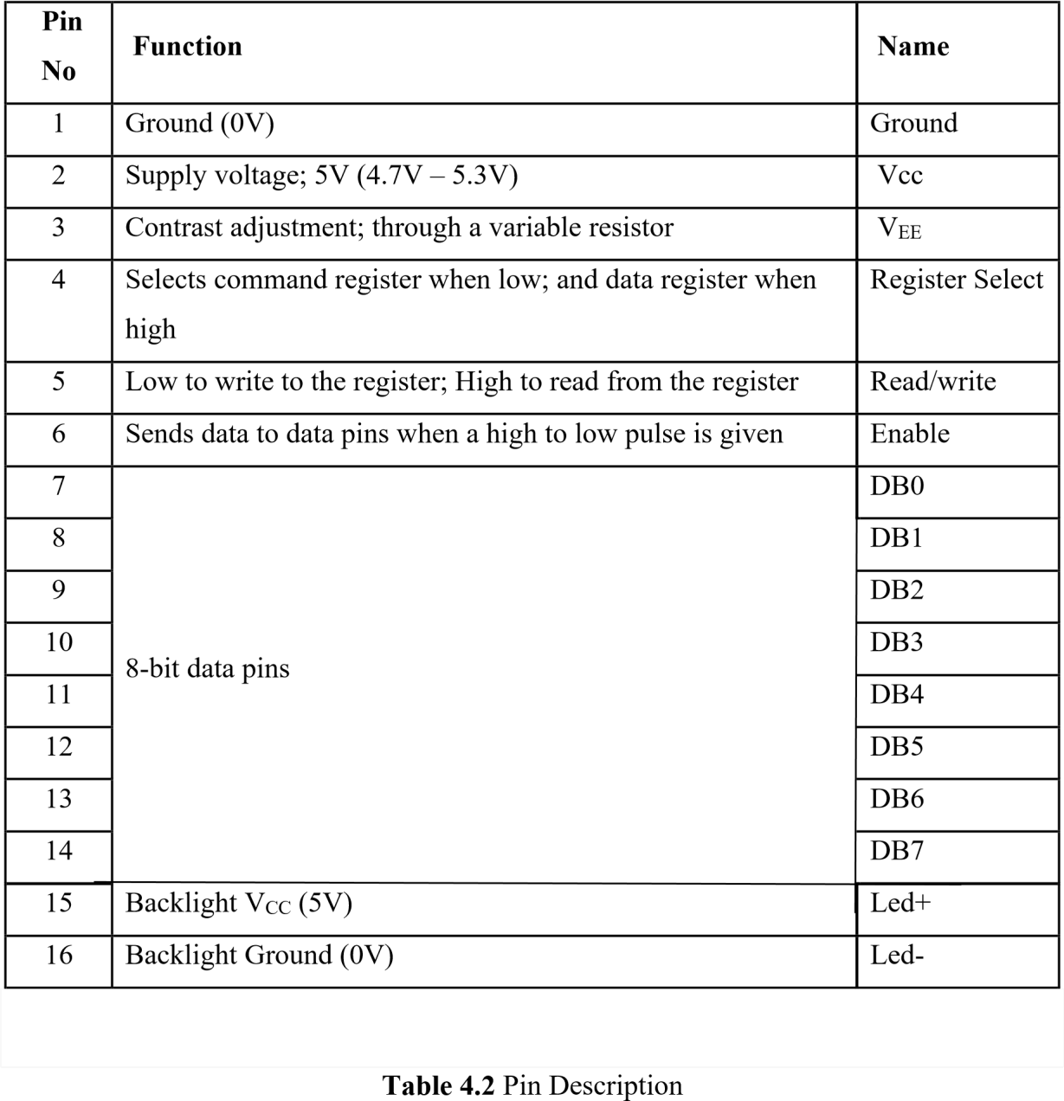

##### Table 4.2 Pin Description

A command is an instruction given to LCD to do a predefined task like initializing it, clearing its screen, setting the cursor position, controlling display etc. The data register stores the data to be displayed on the LCD. The data is the ASCII value of the character to be displayed on the LCD. Click to learn more about internal structure of a [LCD.](http://www.engineersgarage.com/insight/how-lcd-works)

**4.1.4.3 Advantages**

* Very compact and light.
* Low power consumption. On average, 50-70% less energy is consumed.
* No geometric distortion.

**4.1.5 Power Supply**

###### 4.1.5.1 Block diagram

The ac voltage, typically 220V rms, is connected to a transformer, which steps that ac voltage down to the level of the desired dc output. A diode rectifier then provides a full wave rectified voltage that is initially filtered by a simple capacitor filter to produce a dc voltage.



##### Figure 4.9 Block Diagram

A regulator circuit removes the ripples and also remains the same dc value even if the input dc voltage varies, or the load connected to the output dc voltage changes. This voltage regulation is usually obtained using one of the popular voltage regulator IC units.

###### 4.1.5.2 Transformer

The potential transformer will step down the power supply voltage (0-230V) to (06V) level. Then the secondary of the potential transformer will be connected to the precision rectifier, which is constructed with the help of op–amp. The advantages of using precision rectifier are it will give peak voltage output as DC; rest of the circuits will give only RMS output.

###### 4.1.5.3 Bridge rectifier

When four diodes are connected as shown in figure, the circuit is called as bridge rectifier. The input to the circuit is applied to the diagonally opposite corners of the network, and the output is taken from the remaining two corners. Let us assume that the transformer is working properly and there is a positive potential, at point A and a negative potential at point B. the positive potential at point A will forward bias D3 and reverse bias D4.

The negative potential at point B will forward bias D1 and reverse D2. At this time D3 and D1 are forward biased and will allow current flow to pass through them; D4 and D2 are reverse biased and will block current flow. The path for current flow is from point B through D1, up through RL, through D3, through the secondary of the transformer back to point B. this path is indicated by the solid arrows. Waveforms (1) and (2) can be observed across D1 and D3.

###### 4.1.5.4 IC Voltage regulators

Voltage regulators comprise a class of widely used ICs. Regulator IC units contain the circuitry for reference source, comparator amplifier, control device, and overload protection all in a single IC. IC units provide regulation of either a fixed positive voltage, a fixed negative voltage, or an adjustably set voltage. The regulators can be selected for operation with load currents from hundreds of milli amperes to tens of amperes, corresponding to power ratings from milli watts to tens of wattsThis path is indicated by the broken arrows. The current flow through RL is always in the same direction. In flowing through RL this current develops a voltage corresponding to that shown waveform (5). Since current flows through the load (RL) during both half cycles of the applied voltage, this bridge rectifier is a fullwave rectifier

. 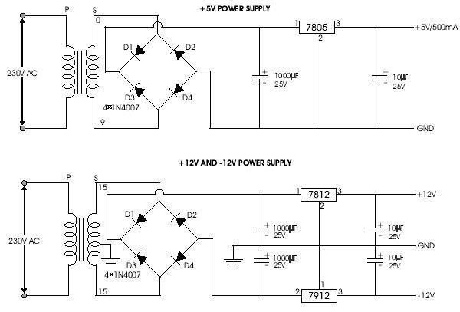

**Figure 4.10** Circuit Diagram

A fixed three-terminal voltage regulator has an unregulated dc input voltage, Vi, applied to one input terminal, a regulated dc output voltage, Vo, from a second terminal, with the third terminal connected to ground. The series 78 regulators provide fixed positive regulated voltages from 5 to 24 volts. Similarly, the series 79 regulators provide fixed negative regulated voltages from 5 to 24 volts.

* For ICs, microcontroller, LCD 5 volts
* For alarm circuit, op-amp, relay circuits 12 volts

###### 4.1.6 GSM

4.1.6.1 GSM technology

GSM refers to second-generation wireless telecommunications standard for digital cellular services. First deployed in Europe, it is based on TDMA (Time Division Multiple Access) technology. GSM uses three frequency bands: 900 MHz, 1800 MHz and 1900 MHz. Dual-band phones operate on two out of three of these frequencies, while tri-band phones operate on all three frequencies.

4.1.6.2 GSM (Global System for Mobile Communications, originally Groupe Spécial Mobile

It is a standard set developed by the European Telecommunications Standards Institute (ETSI) to describe protocols for second generation (2G) digital cellular networks used by mobile phones. The GSM standard was developed as a replacement for first generation (1G) analog cellular networks, and originally described a digital, circuit switched network optimized for full duplex voice telephony. This was expanded over time to include data communications, first by circuit switched transport, then packet data transport via GPRS (General Packet Radio Services) and EDGE (Enhanced Data rates for GSM Evolution or EGPRS).Further improvements were made when the 3GPP developed third generation (3G) UMTS standards followed by fourth generation (4G) LTE Advanced standards."GSM" is a trademark owned by the GSM Association. The mobile station (MS) consists of the physical equipment, such as the radio transceiver, display and digital signal processors, and a smart card called the Subscriber Identity Module (SIM).

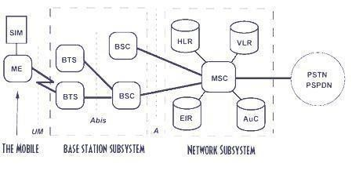

**Figure 4.11** GSM Technology

The SIM provides personal mobility, so that the user can have access to all subscribed services irrespective of both the location of the terminal and the use of a specific terminal. By inserting the SIM card into another GSM cellular phone, the user is able to receive calls at that phone, make calls from that phone, or receive other subscribed services. The mobile equipment is uniquely identified by the International Mobile Equipment Identity (IMEI). The SIM card contains the International Mobile Subscriber Identity (IMSI), identifying the subscriber, a secret key for authentication, and other user information. The IMEI and the IMSI are independent, thereby

SIM Subscriber Identity Module HLR Home Location Register

MS Mobile Station VLR Visitor Location Register

BTS Base Transceiver Station EIR Equipment Identity Register

BSC Base Station Controller AC Authentication Center

MSC Mobile services Switching Center PSTN Public Switched Telecomm Network

VLR Visitor Location Register ISDN Integrated Services Digital Network

###### 4.1.6.3 The Advantages Of GSM

GSM networks enjoy wide international coverage. The use of a SIM (Subscriber Identity Module) card makes it easy to switch between different handsets and allows for the quick and easy import of data such as contacts and text-messages .The amount of battery supported ‘talk-time’ is generally higher on GSM phones.

###### 4.1.6.3 CDMA Technology

CDMA (Code Division Multiple Access) digital wireless technology employs a special coding scheme (whereby each transmitter is assigned a code), which allows multiple users to share common access to the network. Using ‘spread spectrum’ technology, a signal is spread across a broad spectrum of radio frequencies, allowing for a signal with wider bandwidth and increased resistance to interference.

###### 4.1.6.4 The Advantages Of CDMA

CDMA provides wider coverage than GSM and allows for a larger cell area. CDMA enabled calls can be placed in low signal strength conditions, thus CDMA phones offer better reception/coverage in rural areas.

###### 4.1.6.5 3G Technology

Third generation (3G) technology is the newest and most innovative technology available today. 3G mobile-phones and networks offer high data rates, wide bandwidth and increased capacity, all of which are required to support the new range of mobilephone services.

###### 4.1.6.6 Wireless Technology Features

When choosing a wireless service or device to use, you are advised to consider your requirement for the following features. The MAX232 is an integrated circuit, first created by Maxim Integrated Products, that converts signals from an RS-232 serial port to signals suitable for use in TTL compatible digital logic circuits. The MAX232 is a dual driver/receiver and typically converts the RX, TX, CTS and RTS signals.

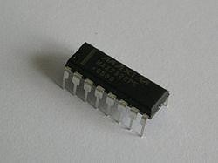

#### Figure 4.12 IC Diagram

A fixed three-terminal voltage regulator has an unregulated dc input voltage, Vi, applied to one input terminal, a regulated dc output voltage, Vo, from a second terminal, with the third terminal connected to ground. The series 78 regulators provide fixed positive regulated voltages from 5 to 24 volts. Similarly, the series 79 regulators provide fixed negative regulated voltages from 5 to 24 volts.

A command is an instruction given to LCD to do a predefined task like initializing it, clearing its screen, setting the cursor position, controlling display etc. The data register stores the data to be displayed on the LCD. The data is the ASCII value of the character to be displayed on the LCD. Click to learn more about internal structure of a [LCD.](http://www.engineersgarage.com/insight/how-lcd-works)

**4.1.7 Buzzer**

A buzzer is a loud noise maker. Most modern ones are civil defense or air- raid sirens, tornado sirens, or the sirens on emergency service vehicles such as ambulances, police cars and fire trucks. There are two general types, pneumatic and electronic.

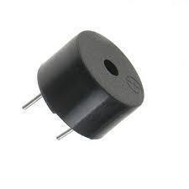

**Figure 4.13** Buzzer

##### 4.1.8 DC Motor

Motor is a device that creates motion, not an engine; it usually refers to either an electrical motor or an internal combustion engine. In most common DC motors (and all that BEAM will see), the external magnetic field is produced by high-strength permanent magnets. The stator is the stationary part of the motor - this includes the motor casing, as well as two or more permanent magnet pole pieces. The rotor (together with the axle and attached commutator) rotate with respect to the stator.

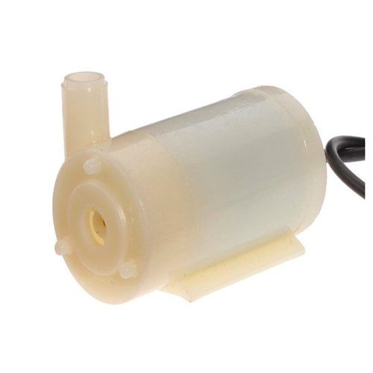

**Figure 4.14** DC Motor

The rotor consists of windings (generally on a core), the windings being electrically connected to the commutator. The above diagram shows a common motor layout -- with the rotor inside the stator (field) magnets. The external magnetic field is produced by high-strength permanent magnets. The stator is the stationary part of the motor - this includes the motor casing, as well as two or more permanent magnet pole pieces.

##### 4.1.9 Smoke Sensor

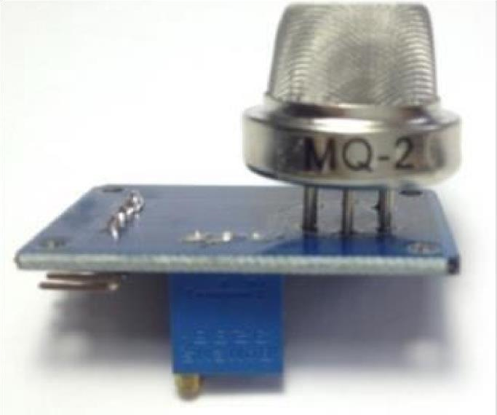

**Figure 4.15** Smoke Sensor

A smoke sensor is a device that senses smoke, typically as an indicator of fire. the

Commercial and residential security devices issue a signal to a fire alarm control panel as part of a fire alarm system, while household detectors, known as smoke alarms, generally issue a local audible or visual alarm from the detector itself. The Analog Smoke/LPG/CO Gas Sensor (MQ2) module utilizes an MQ-2 as the sensitive component and has a protection resistor and an adjustable resistor on board. The MQ-2 gas sensor is sensitive to LPG, ibutane, propane, methane, alcohol, Hydrogen and smoke. It could be used in gas leakage detecting equipment’s in family and industry. When the target combustible gas exist, the sensors conductivity is higher along with the gas concentration rising. Please use simple electronic circuit convert change of conductivity to correspond output signal of gas concentration. MQ-2 gas sensor has high sensitivity to LPG, Propane and Hydrogen, also could be used to Methane and other combustible steam, it is with low cost and suitable for different application.

###### 4.1.10 Image processing

Image processing is the technique to convert an image into digital format and perform operations on it to get an enhanced image or extract some useful information from it. Changes that take place in images are usually performed automatically and rely on carefully designed algorithms. Image processing is a multidisciplinary field, with contributions from different branches of science including mathematics, physics, optical and electrical engineering. Moreover, it overlaps with other areas such as pattern recognition, machine learning, artificial intelligence and human vision research. Different steps involved in image processing include importing the image with an optical scanner or from a digital camera, analysing and manipulating the image (data compression, image enhancement and filtering), and generating the desired output image. The need to extract information from images and interpret their content has been the driving factor in the development of image processing. Image processing finds use in numerous sectors, including medicine, industry, military, and consumer electronics and so on. In medicine, it is used for diagnostic imaging modalities such as digital radiography, positron emission tomography (PET), computerized axial tomography (CAT), magnetic resonance imaging (MRI) and functional magnetic resonance imaging (FMRI).

###### 4.2 SOFTWARE DESCRIPTION

* Embedded C
* Proteus

4.2.1 Embedded C

An embedded system is an application that contains at least one programmable computer (typically in the form of a microcontroller, a microprocessor or digital signal processor chip) and which is used by individuals who are, in the main, unaware that the system is computer-based.

4.2.1.1 Introduction

Looking around, we find ourselves to be surrounded by various types of [embedded systems. Be](http://www.engineersgarage.com/articles/embedded-systems) it a digital camera or a mobile phone or a washing machine, all of them has some kind of processor functioning inside it. Associated with each processor is the embedded software. If hardware forms the body of an embedded system, embedded processor acts as the brain, and embedded software forms its soul. It is the embedded software which primarily governs the functioning of embedded systems. During infancy years of microprocessor based systems, programs were developed using assemblers and fused into the EPROMs. There used to be no mechanism to find what the program was doing. LEDs, switches, etc. were used to check correct execution of the program. Some ‘very fortunate’ developers had In-circuit Simulators (ICEs), but they were too costly and were not quite reliable as well.

As time progressed, use of microprocessor-specific assembly-only as the programming language reduced and embedded systems moved onto C as the embedded programming language of choice. C is the most widely used programming language for embedded processors/controllers. Assembly is also used but mainly to implement those portions of the code where very high timing accuracy, code size efficiency, etc. are prime requirements. Initially C was developed by Kernighan and Ritchie to fit into the space of 8K and to write (portable) operating systems. Originally it was implemented on UNIX operating systems. As it was intended for operating systems development, it can manipulate memory addresses. Also, it allowed programmers to write very compact codes. This has given it the reputation as the language of choice for hackers too.

4.2.1.2 Embedded Systems Programming

Embedded systems programming is different from developing applications on a desktop computers. Key characteristics of an embedded system, when compared to PCs, are as follows. Embedded devices have resource constraints (limited ROM, limited RAM, limited stack space, less processing power) Components used in embedded system and PCs are different; embedded systems typically uses smaller, less power consuming components. Embedded systems are more tied to the hardware. Two salient features of Embedded Programming are code speed and code size. Code speed is governed by the processing power, timing constraints, whereas code size is governed by available program memory and use of programming language. Goal of embedded system programming is to get maximum features in minimum space and minimum time. Embedded systems are programmed using different type of language

* Machine Code
* Low level language, i.e., assembly
* High level language like C, C++, Java, Ada, etc.
* Application level language like Visual Basic, scripts, Access, etc.

Assembly language maps mnemonic words with the binary machine codes that the processor uses to code the instructions. Assembly language seems to be an obvious choice for programming embedded devices. However, use of assembly language is restricted to developing efficient codes in terms of size and speed. Also, assembly codes lead to higher software development costs and code portability is not there. Developing small codes are not much of a problem, but large programs/projects become increasingly difficult to manage in assembly language. Finding good assembly programmers has also become difficult nowadays. Hence high level languages are preferred for embedded systems programming. Use of C in embedded systems is driven by following advantages it is small and reasonably simpler to learn, understand, program and debug. C Compilers are available for almost all embedded devices in use today, and there is a large pool of experienced C programmers.

Unlike assembly, C has advantage of processor-independence and is not specific to any particular microprocessor/ microcontroller or any system. This makes it convenient for a user to develop programs that can run on most of the systems. As C combines functionality of assembly language and features of high level languages, C is treated as a ‘middle-level computer language’ or ‘high level assembly language’. It is fairly efficient. It supports access to I/O and provides ease of management of large embedded projects. Many of these advantages are offered by other languages also, but what sets C apart from others like Pascal, FORTRAN, etc. is the fact that it is a middle level language; it provides direct hardware control without sacrificing benefits of high level languages. Compared to other high level languages, C offers more flexibility because C is relatively small, structured language; it supports low-level bit-wise data manipulation. Compared to assembly language, C Code written is more reliable and scalable, more portable between different platforms (with some changes). Moreover, programs developed in C are much easier to understand, maintain and debug. Also, as they can be developed more quickly, codes written in C offers better productivity. C is based on the philosophy ‘programmers know what they are doing’; only the intentions are to be stated explicitly. It is easier to write good code in C & convert it to an efficient assembly code (using high quality compilers) rather than writing an efficient code in assembly itself. Benefits of assembly language programming over C are negligible when we compare the ease with which C programs are developed by programmers.

Objected oriented language, C++ is not apt for developing efficient programs in resource constrained environments like embedded devices. Virtual functions & exception handling of C++ are some specific features that are not efficient in terms of space and speed in embedded systems. Sometimes C++ is used only with very few features, very much as C.

Ada, also an object-oriented language, is different than C++. Originally designed by the U.S.

DOD, it didn’t gain popularity despite being accepted as an international standard twice (Ada83 and Ada95). However, Ada language has many features that would simplify embedded software development.

Java is another language used for embedded systems programming. It primarily finds usage in high-end mobile phones as it offers portability across systems and is also useful for browsing applications. Java programs require Java Virtual Machine (JVM), which consume lot of resources. Hence it is not used for smaller embedded devices. Dynamic C and B# are some proprietary languages which are also being used in embedded applications. Efficient embedded [C programs mus](http://www.engineersgarage.com/c-language-programs)t be kept small and efficient; they must be optimized for code speed and code size. Good understanding of processor architecture embedded C programming and debugging tools facilitate this

4.2.1.3 Keil C51 C Compilers

* Direct C51 to generate a listing file
* Define manifest constants on the command line
* Control the amount of information included in the object file
* Specify the level of optimization to use
* Specify the memory models

Specify the memory space for variables The Keil C51 C Compiler for the 8051 microcontroller is the most popular 8051 C compiler in the world. It provides more features than any other 8051 C compiler available today.

The C51 Compiler allows you to write 8051 microcontroller applications in C that, once compiled, have the efficiency and speed of assembly language. Language extensions in the C51 Compiler give you full access to all resources of the 8051.

The C51 Compiler translates C source files into reloadable object modules which contain full symbolic information for debugging with the µVision Debugger or an incircuit emulator. In addition to the object file, the compiler generates a listing file which may optionally include symbol table and cross reference information.

**CHAPTER 5**

### RESULT AND DISCUSSIONS

Thus this project carries a great social relevance as it aims to address this problem. This project will help farmers in protecting their orchards and fields and save them from significant financial losses and will save them from the unproductive efforts that they endure for the protection their fields. This will also help them in achieving better crop yields thus leading to their economic wellbeing.

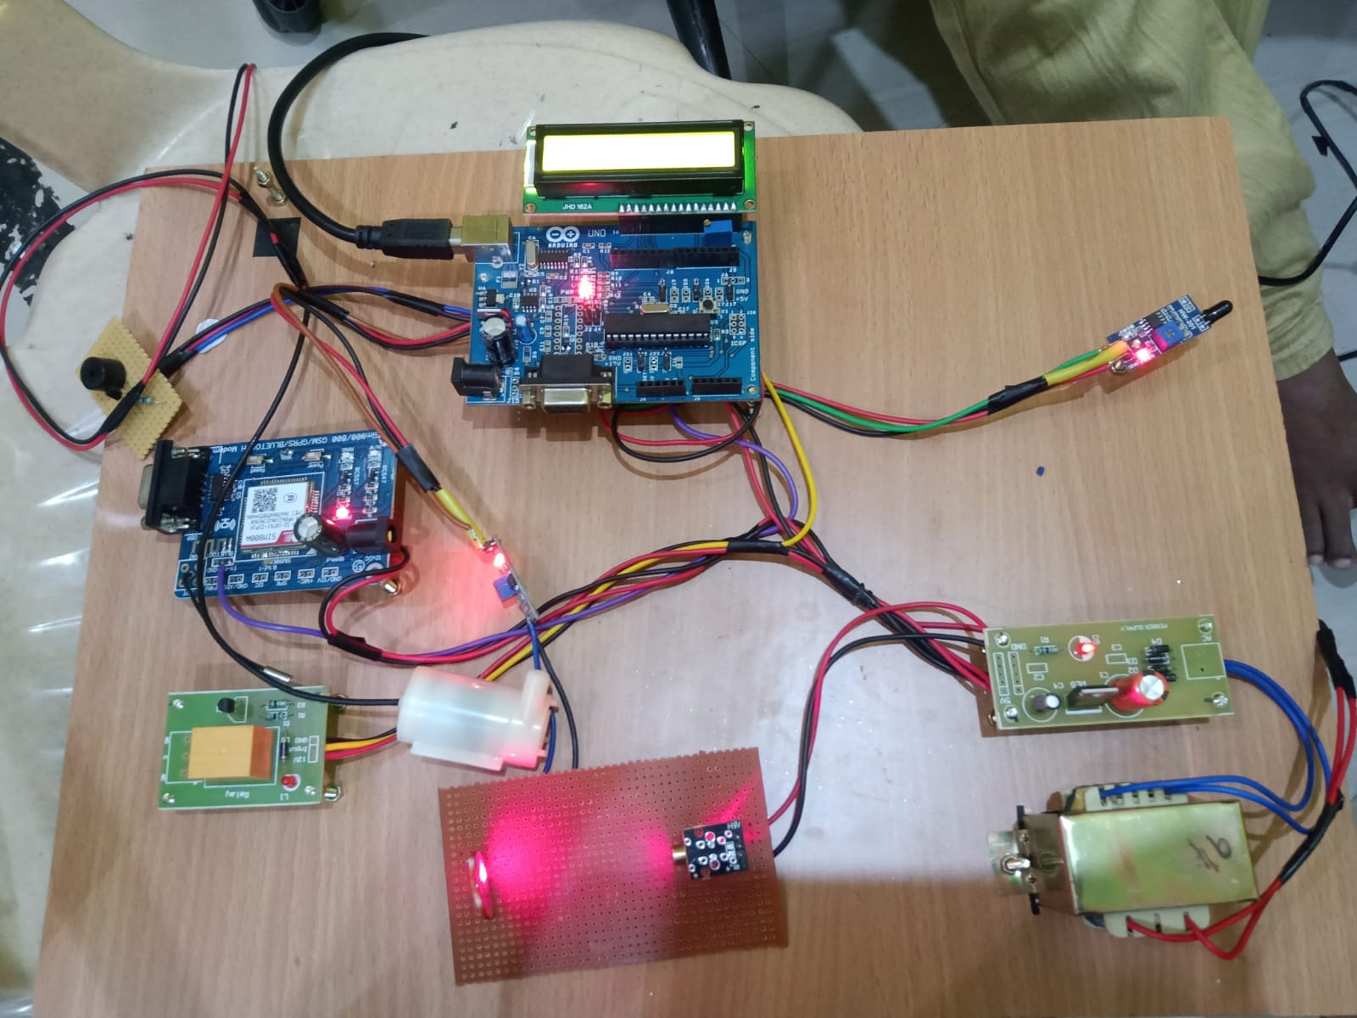

**Figure 5.1** Project Kit

**CONCLUSION AND FUTURE ENHANCEMENTS**

The problem of crop vandalization by wild animals and fire has become a major social problem in current time. It requires urgent attention as no effective solution exists till date for this problem. Thus, this project carries a great social relevance as it aims to address this problem. This project will help farmers in protecting their orchards and fields and save them from significant financial losses and will save them from the unproductive efforts that they endure for the protection their fields. This will also help them in achieving better crop yields thus leading to their economic wellbeing

**CHAPTER 7**

mport cv2

import numpy as np

import serial

with open("data/obj.txt", 'r') as classes_file:

CLASSES = dict(enumerate([line.strip() for line in classes_file.readlines()]))

conf_threshold = 0.3

net = cv2.dnn.readNet("data/last.weights","data/custom.cfg")

def get_bounding_boxes(image):

# create image blob

scale = 0.00392

image_blob = cv2.dnn.blobFromImage(image, scale, (416, 416), (0, 0, 0), True, crop=False)

# detect objects

net.setInput(image_blob)

layer_names = net.getLayerNames()

output_layers = [layer_names[i[0] - 1] for i in net.getUnconnectedOutLayers()]

outputs = net.forward(output_layers)

# print(outputs)

classes = []

classid=[]

confidences = []

boxes = []

nms_threshold = 0.4

for output in outputs:

for detection in output:

scores = detection[5:]

class_id = np.argmax(scores)

confidence = scores[class_id]

if confidence > conf_threshold and CLASSES[class_id]:

width = image.shape[1]

height = image.shape[0]

center_x = int(detection[0] * width)

center_y = int(detection[1] * height)

w = int(detection[2] * width)

h = int(detection[3] * height)

x = center_x - w / 2

y = center_y - h / 2

classes.append(CLASSES[class_id])

classid.append(class_id)

confidences.append(float(confidence))

boxes.append([x, y, w, h])

# remove overlapping bounding boxes

indices = cv2.dnn.NMSBoxes(boxes, confidences, conf_threshold, nms_threshold)

_bounding_boxes = []

_classes = []

_classesid = []

_confidences = []

for i in indices:

i = i[0]

_bounding_boxes.append(boxes[i])

_classes.append(classes[i])

_classesid.append(classid[i])

_confidences.append(confidences[i])

return _classes

cap = cv2.VideoCapture(0)

dev_ser = "COM3"

ser = serial.Serial(dev_ser, 9600, timeout=2)

success, img = cap.read()

# img=cv2.imread('10.jpg')

# cv2.imshow('img',img)

out=get_bounding_boxes(img)

print(out[0])

if(out[0]=="Lion"):

print("1")

ser.write(str("*1\n").encode())

if(out[0]=="Tiger"):

print("2")

ser.write(str("*2\n").encode())

if(out[0]=="Elephant"):

print("3")

ser.write(str("*3\n").encode())

if(out[0]=="Cheetah"):

print("4")

ser.write(str("*4\n").encode())

if(out[0]=="Deer"):

print("5")

ser.write(str("*5\n").encode())

#if(out[0]=="Bear"):

# print("6")

# ser.write(str("*6\n").encode())

#### REFERENCES

1. Astif bherani, Gauravkumar N. raut, pawan D. kale smart design of microcontroller monitoring system for agriculture,” international conference on circuit, power .
2. Chourey S. R., P. A. Amale et al, IETE Zonal Seminar “Recent Trends in Engineering & Technology”-2017 Special Issue of International Journal of Electronics, Communication & Soft Computing Science and Engineering, ISSN: 2277-9477.
3. James P.GIBBS- “Effective Monitoring for Adaptive Wildlife Management: Lessons from the Galapagos Island” Journal of Wildlife Management(May 2015).
4. Joshi V.Bhange S.Chopade-“Wildlife Animal location detection and ealth

Monitoring System” International Journal of Engineering Research and Technology Vol.03 Issue:11 (Nov-2014).

1. Khtatal Sachin Sahebrao-“GPS/GSM based animal tracking and health monitoring system”, International Journal of Engineering, Education and Technology Vol.03 Issue 02(April 2015).
2. Kshama s.Bhise-“Wildlife Animal Tracking using RFID and GSM technology”, International Journal of Scientific and Engineering Research, Vol.07 Issue:02(Feb2016).
3. R. Padula and W. Head, “Fencing System” Project Report published by University of Minnesota, 2003.
4. T . Day and R. Mac Gibbon, “Multiple-Species Exclusion Fencing and Technology for Mainland Sites.”, Project Report published by National Wildlife Research Centre, 2007.
5. V. Deshpande, International Journal of Science and Research (IJSR) ISSN (Online): 2319-7064 Index Copernicus Value (2013): 6.14 | Impact Factor (2014): 5.611.
6. Dr. Wilson, "ELECTRIC FENCE," Handbook of Texas, Project report published by the Texas State Historical Association. August 4, 2011

